《石油地震检波器测试评价规范》

第1部分：速度型动圈检波器

试验报告

《石油地震检波器测试评价规范第1部分：速度型动圈检波器》
编写组
2026年06月

目 录
一、计量要求实验报告 3
二、通用技术要求实验报告A 10
三、通用技术要求实验报告B 32

实 验 报 告

实验报告分为计量要求和通用技术要求两部分。

一、计量要求实验报告
J1 试验目的
通过试验验证《石油地震检波器测试评价规范 第1部分：速度型动圈检波器》条款10.2-10.5自然频率、直流电阻、灵敏度和阻尼系数的实验方法及数据处理的可行性，条款6计量要求的合理性。本报告以条款10.5灵敏度为例。
失真度、绝缘电阻等与此类似实验报告的不再赘述。
J2试验方法
振动台
J3试验内容
J3.1 被测对象
选择不同时期、不同型号、不同厂家的近180只检波器检波器
J3.2实验条件 本规范10.1参考条件
J3.3 试验标准设备
垂直振动台 CZB-5-1
J3.4 测量方法
依次将被测检波器安置于振动台上，以频率80Hz速度10mm/s驱动振动台测试记录检波器的灵敏度。
J3.5 数据和处理
按公式计算参考灵敏度值与检波器标称灵敏度的相对误差。
(1)
式中：
——相对误差；
——实测值；
——被测参数的标称值。
灵敏度测试结果统计表1
序号 | 编号 | 标称灵敏度 | 参考灵敏度 | 误差
1 | G01 | 21.0 | 20.8 | -0.57%
2 | G02 | 21.0 | 20.7 | -1.15%
3 | G03 | 21.0 | 21.0 | 0.24%
4 | G04 | 21.0 | 20.7 | -1.19%
5 | G05 | 21.0 | 20.8 | -0.62%
6 | G06 | 22.8 | 22.5 | -1.18%
7 | G07 | 22.8 | 22.4 | -1.71%
8 | G08 | 22.8 | 22.6 | -1.01%
9 | G09 | 22.8 | 22.6 | -1.05%
10 | G10 | 22.8 | 22.4 | -1.71%
11 | N01 | 20.1 | 20.5 | 2.19%
12 | N02 | 20.1 | 20.1 | -0.10%
13 | N03 | 20.1 | 20.7 | 2.89%
14 | N04 | 20.1 | 20.1 | 0.15%
15 | N05 | 20.1 | 20.5 | 1.94%
16 | N06 | 20.1 | 19.7 | -2.09%
17 | N07 | 20.1 | 19.8 | -1.59%
18 | N08 | 20.1 | 19.8 | -1.59%
19 | N09 | 20.1 | 19.9 | -1.00%
20 | N10 | 20.1 | 19.7 | -1.99%
21 | N11 | 20.1 | 20.3 | 0.75%
22 | N12 | 20.1 | 20.4 | 1.69%
23 | N13 | 20.1 | 20.3 | 0.95%
24 | N14 | 20.1 | 20.2 | 0.45%
25 | N15 | 20.1 | 20.5 | 1.94%
26 | N16 | 20.1 | 20.6 | 2.69%
27 | N17 | 20.1 | 20.5 | 2.04%
28 | N18 | 20.1 | 20.0 | -0.65%
29 | N19 | 20.1 | 20.3 | 1.00%
30 | N20 | 20.1 | 19.9 | -1.04%
31 | N21 | 20.1 | 20.0 | -0.35%
32 | N22 | 20.1 | 19.9 | -0.80%
33 | N23 | 20.1 | 20.1 | -0.25%
34 | N24 | 20.1 | 20.1 | -0.25%
35 | N25 | 20.1 | 20.4 | 1.24%
36 | S01 | 20.9 | 20.7 | -1.00%
37 | S02 | 20.9 | 20.6 | -1.44%
38 | S03 | 20.9 | 20.8 | -0.29%
39 | S04 | 20.9 | 20.8 | -0.33%
40 | S05 | 20.9 | 20.8 | -0.48%
41 | S06 | 22.8 | 22.8 | 0.13%
42 | S07 | 22.8 | 23.1 | 1.10%
43 | S08 | 22.8 | 23.0 | 0.88%
44 | S09 | 22.8 | 22.9 | 0.39%
45 | S10 | 22.8 | 23.1 | 1.45%
46 | S11 | 20.1 | 20.4 | 1.34%
47 | S12 | 20.1 | 20.6 | 2.34%
48 | S13 | 20.1 | 20.5 | 1.89%
49 | S14 | 20.1 | 20.5 | 1.99%
50 | S15 | 20.1 | 20.5 | 1.79%
51 | S16 | 20.1 | 20.4 | 1.29%
52 | S17 | 20.1 | 20.3 | 1.09%
53 | S18 | 20.1 | 20.3 | 1.19%
54 | S19 | 20.1 | 20.4 | 1.29%
55 | S20 | 20.1 | 20.2 | 0.60%
56 | S21 | 20.1 | 20.5 | 1.84%
57 | S22 | 20.1 | 20.4 | 1.64%
58 | S23 | 20.1 | 20.5 | 1.74%
59 | S24 | 20.1 | 20.4 | 1.29%
60 | S25 | 20.1 | 20.6 | 2.69%
61 | S26 | 20.1 | 20.5 | 2.09%
62 | S27 | 20.1 | 20.3 | 1.09%
63 | S28 | 20.1 | 20.5 | 1.79%
64 | S29 | 20.1 | 20.3 | 1.19%
65 | S30 | 20.1 | 20.3 | 1.19%
66 | CD01 | 80.0 | 79.2 | -1.06%
67 | CD02 | 80.0 | 79.5 | -0.66%
68 | CD03 | 80.0 | 82.0 | 2.50%
69 | CD04 | 80.0 | 79.9 | -0.08%
70 | CD05 | 80.0 | 80.7 | 0.82%
71 | CD06 | 83.2 | 83.2 | 0.02%
72 | CD07 | 80.0 | 81.4 | 1.79%
73 | EF01 | 85.8 | 87.5 | 2.00%
74 | EF02 | 78.7 | 80.1 | 1.73%
75 | EF03 | 85.8 | 85.2 | -0.68%
76 | EF04 | 85.8 | 87.3 | 1.72%
77 | EF05 | 85.8 | 86.1 | 0.34%
78 | EF06 | 85.8 | 86.3 | 0.62%
79 | AB01 | 20.1 | 19.9 | -1.23%
80 | AB02 | 20.1 | 20.9 | 3.87%
81 | AB03 | 20.1 | 20.7 | 2.78%
82 | AB04 | 20.1 | 20.3 | 1.18%
83 | AB05 | 20.1 | 20.3 | 0.79%
84 | AB06 | 20.1 | 20.4 | 1.26%
85 | AB07 | 20.1 | 20.4 | 1.48%
86 | G-01 | 28.8 | 28.6 | -0.72%
87 | G-02 | 28.8 | 29.2 | 1.27%
88 | G-03 | 28.8 | 29.8 | 3.34%
89 | G-04 | 32.5 | 31.3 | -3.59%
本表数据含七种不同型号不同时期不同厂家的检波器89只。

灵敏度测试结果统计图1

灵敏度测试结果统计表2
振动台 | 频率 | 80 Hz | 速度 | 10 mm/s
序号 | 编号 | 标称灵敏度 | 参考灵敏度 | 误差
1 | N-01 | 20.1 | 20.43 | 1.64%
2 | N-02 | 20.1 | 20.65 | 2.74%
3 | N-03 | 20.1 | 20.45 | 1.74%
4 | N-04 | 20.1 | 20.49 | 1.94%
5 | N-05 | 20.1 | 20.37 | 1.34%
6 | N-06 | 20.1 | 20.04 | -0.30%
7 | N-07 | 20.1 | 20.23 | 0.65%
8 | N-08 | 20.1 | 20.08 | -0.10%
9 | N-09 | 20.1 | 19.99 | -0.55%
10 | N-10 | 20.1 | 19.91 | -0.95%
11 | N-11 | 20.1 | 20.45 | 1.74%
12 | N-12 | 20.1 | 20.28 | 0.90%
13 | N-13 | 20.1 | 20.49 | 1.94%
14 | N-14 | 20.1 | 20.45 | 1.74%
15 | N-15 | 20.1 | 20.3 | 1.00%
16 | N-16 | 20.1 | 20.43 | 1.64%
17 | N-17 | 20.1 | 20.68 | 2.89%
18 | N-18 | 20.1 | 20.36 | 1.29%
19 | N-19 | 20.1 | 20.48 | 1.89%
20 | N-20 | 20.1 | 20.79 | 3.43%
21 | N-21 | 20.1 | 20.6 | 2.49%
22 | N-22 | 20.1 | 20.82 | 3.58%
23 | N-23 | 20.1 | 20.9 | 3.98%
24 | N-24 | 20.1 | 20.75 | 3.23%
25 | N-25 | 20.1 | 20.66 | 2.79%
26 | N-26 | 20.1 | 20.32 | 1.09%
27 | N-27 | 20.1 | 19.94 | -0.80%
28 | N-28 | 20.1 | 20.18 | 0.40%
29 | N-29 | 20.1 | 20.21 | 0.55%
30 | N-30 | 20.1 | 20.24 | 0.70%
31 | S-01 | 20.1 | 20.56 | 2.29%
32 | S-02 | 20.1 | 20.3 | 1.00%
33 | S-03 | 20.1 | 20.48 | 1.89%
34 | S-04 | 20.1 | 20.39 | 1.44%
35 | S-05 | 20.1 | 20.38 | 1.39%
36 | S-06 | 20.95 | 21.39 | 2.10%
37 | S-07 | 20.95 | 21.23 | 1.34%
38 | S-08 | 20.95 | 21.4 | 2.15%
39 | S-09 | 20.95 | 21.18 | 1.10%
40 | S-10 | 20.95 | 21.39 | 2.10%
41 | S-11 | 20.1 | 20.51 | 2.04%
42 | S-12 | 20.1 | 20.45 | 1.74%
43 | S-13 | 20.1 | 20.55 | 2.24%
44 | S-14 | 20.1 | 20.4 | 1.49%
45 | S-15 | 20.1 | 20.57 | 2.34%
46 | S-16 | 20.1 | 20.68 | 2.89%
47 | S-17 | 20.1 | 20.74 | 3.18%
48 | S-18 | 20.1 | 20.67 | 2.84%
49 | S-19 | 20.1 | 21.01 | 4.53%
50 | S-20 | 20.1 | 20.65 | 2.74%
51 | S-21 | 20.9 | 21.55 | 3.11%
52 | S-22 | 20.9 | 21.74 | 4.02%
53 | S-23 | 20.9 | 21.78 | 4.21%
54 | S-24 | 20.9 | 21.53 | 3.01%
55 | S-25 | 20.9 | 21.46 | 2.68%
56 | S-26 | 20.1 | 20.26 | 0.80%
57 | S-27 | 20.1 | 20.22 | 0.60%
58 | S-28 | 20.1 | 20.27 | 0.85%
59 | S-29 | 20.1 | 20.26 | 0.80%
60 | S-30 | 20.1 | 20.27 | 0.85%
61 | S-31 | 20.9 | 20.9 | 0.00%
62 | S-32 | 20.9 | 21.03 | 0.62%
63 | S-33 | 20.9 | 20.99 | 0.43%
64 | S-34 | 20.9 | 20.94 | 0.19%
65 | S-35 | 20.9 | 20.91 | 0.05%
66 | S-36 | 20.9 | 20.89 | -0.05%
67 | S-37 | 20.9 | 21.07 | 0.81%
68 | S-38 | 20.9 | 20.98 | 0.38%
69 | S-39 | 20.9 | 20.88 | -0.10%
70 | S-40 | 20.9 | 20.86 | -0.19%
71 | S-41 | 20.9 | 20.83 | -0.33%
72 | S-42 | 20.9 | 20.68 | -1.05%
73 | S-43 | 20.9 | 20.88 | -0.10%
74 | S-44 | 20.9 | 20.71 | -0.91%
75 | S-45 | 20.9 | 20.68 | -1.05%
76 | S-46 | 22.8 | 22.67 | -0.57%
77 | S-47 | 22.8 | 22.81 | 0.04%
78 | S-48 | 22.8 | 22.65 | -0.66%
79 | S-49 | 22.8 | 22.66 | -0.61%
80 | S-50 | 22.8 | 22.56 | -1.05%
81 | S-51 | 22.8 | 23.09 | 1.27%
82 | S-52 | 22.8 | 23.12 | 1.40%
83 | S-53 | 22.8 | 23.13 | 1.45%
84 | S-54 | 22.8 | 23.34 | 2.37%
85 | S-55 | 22.8 | 23.25 | 1.97%

本表数据含两种不同型号不同时期不同厂家的检波器85只。

灵敏度测试结果统计图2
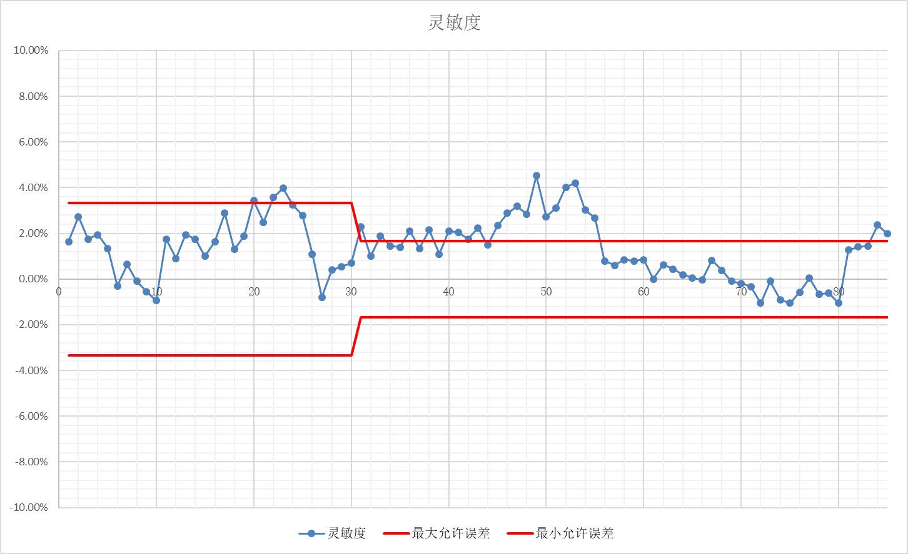

J4试验结论
实验结果证明本规范10.2-10.5条款所使用的测试方法得到了验证，试验要求和试验方法合理可行，具有的可操作性、实用性和科学性。

二、通用技术要求实验报告A
- 试验目的
通过试验验证《石油地震检波器测试评价规范 第1部分：速度型动圈检波器》条款10.10、10.13、10.14工作倾角、工作温度、振动和可靠性的实验方法，试验后的计量参数测试和数据处理的可行性，及相应条款要求的合理性。
- 试验内容
  - 被测对象 检波器
  - 试验标准设备
实验设备符合标准要求
  - 实验条件
本规范10.1参考条件
  - 测量方法和数据处理
测量方法和数据处理等依照本规范相应条款。
  - 实验前测量数据
    - 10Hz检波器测试结果
表2 20DX 10Hz检波器参数表
项目 | 线圈电阻 | 自然频率 | 阻尼系数 | 灵敏度 | 失真度
标称值 | 283.2 | 10.0 | 0.7 | 20.1
最大允许误差 | ±2.5% | ±2.5% | ±2.5% | ±2.5% | 0.10%

表3 20DX 10Hz检波器测试结果表
序号 | 芯体编号 | 电阻 | 频率 | 阻尼 | 灵敏度 | 失真度（%）
1 | AB01 | 1.7% | -0.1% | 0.0% | -0.4% | 0.023
2 | AB02 | 1.8% | -0.4% | 0.0% | -0.5% | 0.024
3 | AB03 | 2.0% | -0.5% | -0.1% | -0.3% | 0.047
4 | AB04 | 1.3% | -0.4% | -0.3% | -0.1% | 0.040
5 | AB05 | 1.8% | -0.3% | 0.0% | -0.4% | 0.036
6 | AB06 | 1.0% | -0.4% | -0.6% | -1.0% | 0.050
7 | AB07 | 1.3% | -0.4% | -0.1% | -0.5% | 0.055
8 | AB08 | 1.7% | -0.9% | -0.3% | -1.0% | 0.035
9 | AB09 | 2.0% | 0.3% | 0.3% | 0.5% | 0.049
10 | AB10 | 2.0% | -0.7% | 0.4% | -0.7% | 0.050
11 | AB11 | 2.4% | -0.3% | -0.4% | 0.1% | 0.036
12 | AB12 | 1.6% | 0.0% | -0.7% | 0.0% | 0.011
13 | AB13 | 1.7% | -0.1% | 0.6% | 0.3% | 0.011
14 | AB14 | 1.7% | -0.2% | 0.1% | 0.7% | 0.017
15 | AB15 | 1.0% | -0.2% | -0.6% | 0.5% | 0.033
16 | AB16 | 1.0% | 0.0% | 1.0% | 0.8% | 0.019
17 | AB17 | 2.7% | 0.5% | -0.3% | 0.6% | 0.043
18 | AB18 | 1.7% | -0.9% | 0.0% | 0.0% | 0.051
19 | AB19 | 3.6% | -0.1% | -0.6% | -1.0% | 0.031
20 | AB20 | 2.4% | 0.0% | 0.3% | -0.2% | 0.033
21 | AB21 | 0.9% | -0.6% | 0.1% | 0.1% | 0.031
22 | AB22 | 0.3% | -0.2% | 0.0% | 1.0% | 0.035
23 | AB23 | 0.6% | -0.9% | 1.0% | 0.5% | 0.024
24 | AB24 | 0.9% | -0.3% | -0.4% | 0.2% | 0.038
25 | AB25 | 1.3% | -0.2% | 0.3% | 0.4% | 0.033
26 | AB26 | 1.3% | -0.3% | 1.4% | 1.0% | 0.058
27 | AB27 | 0.9% | -0.6% | 0.3% | -0.2% | 0.020
28 | AB28 | 0.6% | 0.1% | 0.8% | 0.9% | 0.051
29 | AB29 | 0.6% | -0.2% | 0.6% | 1.0% | 0.069
30 | AB30 | 1.1% | -0.1% | 0.4% | 0.1% | 0.037
31 | AB31 | -0.4% | -0.7% | 0.6% | 0.4% | 0.053
32 | AB32 | -0.8% | -0.3% | 0.7% | 0.5% | 0.017
33 | AB33 | -0.5% | -0.4% | 1.3% | 0.9% | 0.011
34 | AB34 | -0.8% | 0.8% | 0.1% | 0.3% | 0.033
35 | AB35 | -1.1% | -0.4% | 1.1% | 0.4% | 0.028
36 | AB36 | -0.4% | 0.2% | 0.3% | 0.8% | 0.025
37 | AB37 | -1.1% | 1.0% | 0.3% | 0.5% | 0.033
38 | AB38 | -0.8% | -0.1% | 1.0% | 0.4% | 0.015
39 | AB39 | -0.4% | 0.2% | 0.7% | 0.3% | 0.030
40 | AB40 | 0.1% | 0.1% | 1.3% | 0.8% | 0.020
41 | AB41 | 1.3% | -0.3% | -0.3% | 0.2% | 0.018
42 | AB42 | 0.3% | 0.2% | 0.0% | 0.0% | 0.026
43 | AB43 | 0.6% | -0.2% | -0.3% | -0.3% | 0.031
44 | AB44 | 1.7% | -0.6% | -0.6% | -0.5% | 0.011
45 | AB45 | 0.6% | 0.0% | 0.0% | 0.2% | 0.039
46 | AB46 | 0.3% | -0.3% | -0.1% | -0.2% | 0.036
47 | AB47 | 0.9% | -0.6% | -0.1% | -0.4% | 0.026
48 | AB48 | 1.0% | -0.3% | -0.4% | 0.5% | 0.027
49 | AB49 | 1.0% | -0.3% | -0.4% | -0.1% | 0.015
50 | AB50 | 1.3% | -1.0% | -0.6% | -0.5% | 0.016
51 | AB51 | -0.1% | -0.3% | -0.1% | 0.6% | 0.015
52 | AB52 | -0.1% | 0.1% | -0.6% | 0.2% | 0.024
53 | AB53 | -0.4% | -0.5% | -0.3% | 0.5% | 0.011
54 | AB54 | -0.4% | 0.0% | -0.4% | 0.4% | 0.007
55 | AB55 | -0.1% | -0.1% | -0.6% | 0.2% | 0.036
56 | AB56 | -0.1% | -0.3% | -0.3% | 0.3% | 0.030
57 | AB57 | 0.3% | 0.0% | -0.4% | 0.0% | 0.024
58 | AB58 | -0.1% | -0.7% | -0.3% | 0.6% | 0.014
59 | AB59 | 0.3% | 0.4% | -0.4% | 0.0% | 0.023
60 | AB60 | 0.2% | -0.3% | -0.6% | -0.2% | 0.016
61 | AB61 | 1.7% | 0.8% | -0.6% | 0.4% | 0.021
62 | AB62 | 1.3% | 0.9% | -0.8% | -0.2% | 0.033
63 | AB63 | 1.4% | 0.4% | -0.3% | 0.2% | 0.018
64 | AB64 | 1.3% | 0.4% | -0.7% | -0.3% | 0.019
65 | AB65 | 0.6% | 0.9% | 0.0% | 0.5% | 0.016
66 | AB66 | 1.2% | 0.4% | 0.0% | 0.2% | 0.023
67 | AB67 | 1.0% | 0.4% | -0.6% | -0.3% | 0.032
68 | AB68 | 0.6% | 0.6% | -1.0% | 0.4% | 0.017
69 | AB69 | 0.6% | 0.0% | -0.7% | -0.1% | 0.065
70 | AB70 | 0.6% | 0.5% | -0.3% | 0.0% | 0.029

图 1 10Hz检波器线圈电阻、自然频率、阻尼系数和灵敏度相对偏差统计图

图2 10Hz 检波器失真度测试结果统计图
    - 5Hz 检波器测试结果
表4 5Hz检波器参数表A
项目 | 线圈电阻 | 自然频率 | 阻尼系数 | 灵敏度 | 失真度
标称值 | 1850 | 5.0 | 0.6 | 80
最大允许误差 | ±5% | ±5% | ±5% | ±5% | 0.20%

表5 5Hz检波器测试结果表A
序号 | 芯体编号 | 线圈电阻 | 自然频率 | 阻尼系数 | 灵敏度 | 失真度
1 | CD01 | 0.6% | -1.0% | -4.5% | -0.3% | 0.045
2 | CD02 | -0.2% | -1.4% | -1.0% | -0.8% | 0.043
3 | CD03 | 0.1% | -0.2% | -4.0% | 0.0% | 0.054
4 | CD04 | -2.1% | -1.8% | -3.0% | 0.0% | 0.018
5 | CD05 | -1.0% | -0.2% | -2.0% | -1.3% | 0.030
6 | CD06 | -1.1% | -1.8% | -0.7% | -1.1% | 0.047
7 | CD07 | 0.2% | -2.8% | -0.2% | -0.7% | 0.037
8 | CD08 | -0.7% | -2.4% | -1.5% | -0.4% | 0.043
9 | CD09 | 0.9% | -1.6% | -2.7% | -2.6% | 0.030
10 | CD10 | 0.7% | -2.2% | -1.5% | 0.6% | 0.030
11 | CD11 | 1.2% | -0.6% | -0.3% | 0.0% | 0.026
12 | CD12 | 0.3% | -0.2% | -0.2% | -0.3% | 0.031
13 | CD13 | 0.9% | 1.0% | -2.7% | -0.2% | 0.046
14 | CD14 | 0.5% | -1.0% | -0.2% | -0.4% | 0.021
15 | CD15 | 1.0% | -0.4% | -0.2% | 0.7% | 0.035
16 | CD16 | 0.9% | 0.0% | -1.3% | -0.2% | 0.027
17 | CD17 | -0.1% | -1.2% | -0.7% | 0.0% | 0.038
18 | CD18 | -0.1% | -0.8% | -1.3% | -0.3% | 0.032
19 | CD19 | 0.8% | -1.2% | 0.2% | 0.0% | 0.024
20 | CD20 | 0.0% | -1.6% | 0.2% | -0.6% | 0.023
21 | CD21 | -0.4% | -4.2% | 3.0% | 0.3% | 0.054
22 | CD22 | 0.6% | -4.0% | 1.5% | -0.1% | 0.029
23 | CD23 | 0.0% | -4.6% | 3.0% | 0.4% | 0.043
24 | CD24 | -0.9% | -3.6% | 3.5% | -0.1% | 0.034
25 | CD25 | -0.6% | -4.2% | 2.3% | -0.2% | 0.041
26 | CD26 | -0.3% | -4.4% | 4.0% | 2.2% | 0.017
27 | CD27 | -0.3% | -3.0% | 1.7% | 1.9% | 0.024
28 | CD28 | -1.6% | -4.2% | 1.7% | 0.1% | 0.022
29 | CD29 | 0.0% | -4.2% | 0.5% | -0.7% | 0.036
30 | CD30 | -0.4% | -3.8% | 2.8% | 0.1% | 0.029
31 | CD31 | 3.4% | -1.4% | 0.3% | -0.6% | 0.026
32 | CD32 | 1.0% | -0.8% | 0.7% | -0.1% | 0.020
33 | CD33 | 1.0% | -1.0% | -0.5% | 0.2% | 0.032
34 | CD34 | 1.0% | -1.6% | 0.8% | 0.2% | 0.021
35 | CD35 | 1.5% | -0.8% | 0.8% | 0.9% | 0.025
36 | CD36 | 1.0% | -1.0% | -0.2% | 0.5% | 0.022
37 | CD37 | 1.2% | -1.4% | 0.3% | 0.5% | 0.022
38 | CD38 | 1.0% | -1.2% | -0.8% | 0.6% | 0.035
39 | CD39 | 1.5% | -1.2% | 0.2% | 0.5% | 0.017
40 | CD40 | 1.8% | -0.4% | 0.8% | 1.2% | 0.026
41 | CD41 | 0.0% | -1.6% | -0.3% | -0.2% | 0.027
42 | CD42 | -0.3% | -1.0% | 0.2% | 0.5% | 0.033
43 | CD43 | -0.2% | -1.0% | -0.2% | 0.8% | 0.030
44 | CD44 | -0.6% | -0.2% | 0.8% | 1.1% | 0.034
45 | CD45 | -0.4% | -0.6% | 0.3% | 0.7% | 0.032
46 | CD46 | -0.8% | -1.4% | -0.3% | 0.3% | 0.024
47 | CD47 | -0.5% | -0.8% | 0.8% | 0.9% | 0.031
48 | CD48 | -0.7% | -1.0% | 0.7% | 0.7% | 0.028
49 | CD49 | 0.5% | 0.4% | -0.5% | 1.1% | 0.028
50 | CD50 | -0.5% | -0.6% | 0.3% | 1.1% | 0.031
51 | CD51 | 0.7% | 2.6% | 0.5% | 1.0% | 0.029
52 | CD52 | 0.5% | 1.8% | 0.5% | 0.6% | 0.025
53 | CD53 | 0.8% | 1.2% | 1.3% | 2.0% | 0.023
54 | CD54 | 1.4% | 2.6% | -0.8% | 0.4% | 0.020
55 | CD55 | 1.8% | -0.4% | -1.7% | -0.1% | 0.034
56 | CD56 | 1.2% | 3.8% | -1.0% | 1.1% | 0.017
57 | CD57 | 0.0% | 1.0% | -1.2% | -0.3% | 0.017
58 | CD58 | 1.6% | 1.2% | -1.5% | 0.0% | 0.024
59 | CD59 | 0.3% | 2.4% | 0.3% | 2.1% | 0.021
60 | CD60 | 2.0% | 2.8% | -0.7% | 1.3% | 0.028

表6 5Hz检波器参数表B
项目 | 线圈电阻 | 自然频率 | 阻尼系数 | 灵敏度 | 失真度
标称值 | 1920 | 5.0 | 0.6 | 83.2
最大允许误差 | ±5% | ±5% | ±5% | ±5% | 0.20%

表7 5Hz检波器测试结果表B
序号 | 芯体编号 | 线圈电阻 | 自然频率 | 阻尼系数 | 灵敏度 | 失真度
61 | CD61 | 0.0% | -0.2% | -1.0% | -0.5% | 0.020
62 | CD62 | 0.1% | 0.4% | -0.8% | -0.8% | 0.009
63 | CD63 | 0.2% | 0.0% | -1.2% | -0.4% | 0.019
64 | CD64 | 0.3% | -0.2% | -1.2% | -1.0% | 0.009
65 | CD65 | 0.0% | 0.2% | -1.2% | -0.5% | 0.014
66 | CD66 | 0.1% | 0.0% | -1.0% | -0.3% | 0.013
67 | CD67 | 0.2% | -0.4% | -1.2% | -0.9% | 0.013
68 | CD68 | 0.6% | -0.4% | -0.8% | -0.7% | 0.019
69 | CD69 | -0.1% | 0.2% | -1.0% | -0.6% | 0.018
70 | CD70 | -0.2% | -0.2% | -1.0% | -0.4% | 0.009

图3 5Hz检波器线圈电阻、自然频率、阻尼系数和灵敏度相对偏差统计图

图4 5Hz检波器失真度测试结果统计图

    - 10Hz高灵敏度检波器测试结果
10Hz高灵敏度检波器是近年来新开发的产品，不同厂家的参数不同，产品质量参差不一。
表8 10Hz高灵敏度检波器参数表A
项目 | 线圈电阻 | 自然频率 | 阻尼系数 | 灵敏度 | 失真度
标称值 | 1800 | 10 | 0.510 | 85.8
最大允许误差 | ±5% | ±5% | ±5% | ±5% | 0.10%

表9 5Hz检波器测试结果表A
序号 | 芯体编号 | 线圈电阻 | 自然频率 | 阻尼系数 | 灵敏度 | 失真度
1 | EF01 | 0.1% | -0.6% | -0.2% | 0.5% | 0.017
2 | EF02 | 0.1% | -0.3% | 1.6% | 0.2% | 0.021
3 | EF03 | 1.3% | -0.9% | -2.5% | -2.1% | 0.013
4 | EF04 | 1.6% | -1.9% | -1.6% | -1.5% | 0.021
5 | EF05 | 0.6% | -0.9% | 0.8% | -0.9% | 0.040
6 | EF06 | 0.2% | -0.6% | -1.8% | -0.3% | 0.016
7 | EF07 | 0.8% | -0.5% | 0.2% | -0.1% | 0.034
8 | EF08 | 0.9% | -1.2% | -1.2% | -0.8% | 0.019
9 | EF09 | 0.9% | -0.7% | 0.8% | 0.1% | 0.016
10 | EF10 | 0.9% | -0.5% | 0.0% | -0.1% | 0.025
11 | EF31 | 0.3% | 0.1% | -0.4% | 0.2% | 0.021
12 | EF32 | -0.1% | -0.1% | -1.2% | -0.3% | 0.025
13 | EF33 | 0.0% | -0.4% | -1.0% | -0.1% | 0.022
14 | EF34 | 0.1% | 0.0% | -1.6% | -0.6% | 0.033
15 | EF35 | 0.4% | -0.2% | -0.6% | -0.1% | 0.034
16 | EF36 | 0.5% | 0.4% | -1.2% | -0.2% | 0.050
17 | EF37 | 0.0% | -0.3% | -1.0% | 0.0% | 0.031
18 | EF38 | 0.4% | -0.2% | -2.0% | -0.7% | 0.032
19 | EF39 | 0.8% | -0.7% | -0.6% | -0.3% | 0.054
20 | EF40 | 0.7% | -0.3% | -0.6% | -0.1% | 0.031
21 | EF61 | 0.2% | 0.5% | 0.0% | 0.3% | 0.037
22 | EF62 | 0.8% | 1.0% | -1.0% | -0.2% | 0.025
23 | EF63 | 0.6% | 0.6% | 0.8% | -0.1% | 0.017
24 | EF64 | 0.5% | 0.9% | -0.6% | 0.3% | 0.016
25 | EF65 | 1.5% | 0.2% | -0.2% | 0.0% | 0.026
26 | EF66 | 0.8% | 0.6% | -1.2% | 0.0% | 0.018
27 | EF67 | 0.6% | 0.2% | -1.0% | 0.0% | 0.026
28 | EF68 | 0.9% | 0.5% | -0.8% | -0.2% | 0.032
29 | EF69 | 0.9% | 0.5% | 0.0% | 0.4% | 0.021
30 | EF70 | 1.2% | 0.3% | -0.8% | 0.0% | 0.020

表10 10Hz高灵敏度检波器参数表B
项目 | 线圈电阻 | 自然频率 | 阻尼系数 | 灵敏度 | 失真度
标称值 | 1800 | 10 | 0.560 | 85.8
最大允许误差 | ±5% | ±5% | ±5% | ±5% | 0.10%

表11 10Hz检波器测试结果表B
序号 | 芯体编号 | 线圈电阻 | 自然频率 | 阻尼系数 | 灵敏度 | 失真度
31 | EF41 | 0.9% | -0.8% | -0.7% | -0.3% | 0.016
32 | EF42 | 0.3% | -0.6% | -0.4% | -0.2% | 0.053
33 | EF43 | -0.2% | -0.4% | -0.4% | -0.3% | 0.019
34 | EF44 | 0.0% | -0.4% | -0.4% | 0.0% | 0.009
35 | EF45 | 0.1% | 0.1% | -0.7% | 0.3% | 0.017
36 | EF46 | 0.7% | -0.4% | -0.7% | 0.1% | 0.026
37 | EF47 | 0.3% | -0.3% | -0.5% | -0.5% | 0.032
38 | EF48 | 0.6% | -0.4% | -0.5% | 0.3% | 0.012
39 | EF49 | 0.2% | -0.9% | -0.5% | -0.2% | 0.017
40 | EF50 | -0.2% | -0.9% | -0.9% | -0.4% | 0.011
41 | EF51 | 0.9% | -0.1% | -0.7% | 0.0% | 0.019
42 | EF52 | 0.2% | -0.2% | -0.9% | 0.0% | 0.015
43 | EF53 | 0.3% | -0.1% | -0.4% | -0.1% | 0.023
44 | EF54 | 0.2% | -0.1% | -0.4% | -0.3% | 0.022
45 | EF55 | -0.1% | 0.0% | -0.4% | -0.1% | 0.022
46 | EF56 | 0.5% | -0.2% | 0.2% | 0.0% | 0.019
47 | EF57 | -0.3% | -0.4% | 0.4% | -0.1% | 0.016
48 | EF58 | -0.2% | -0.2% | -0.2% | 0.2% | 0.022
49 | EF59 | 0.2% | 0.0% | 0.0% | 0.1% | 0.018
50 | EF60 | 0.3% | 0.1% | -0.5% | 0.0% | 0.010

表12 10Hz高灵敏度检波器参数表C
项目 | 线圈电阻 | 自然频率 | 阻尼系数 | 灵敏度 | 失真度
标称值 | 1651 | 10 | 0.700 | 78.7
最大允许误差 | ±5% | ±5% | ±5% | ±5% | 0.10%

表13 10Hz检波器测试结果表C
序号 | 芯体编号 | 线圈电阻 | 自然频率 | 阻尼系数 | 灵敏度 | 失真度
51 | EF21 | 0.7% | 0.1% | 0.0% | 0.3% | 0.028
52 | EF22 | 0.7% | 0.2% | 0.4% | 0.7% | 0.030
53 | EF23 | 1.0% | -0.3% | 0.0% | -0.3% | 0.032
54 | EF24 | 1.6% | -0.3% | 0.3% | -0.3% | 0.014
55 | EF25 | 1.4% | -0.1% | 0.1% | -0.1% | 0.014
56 | EF26 | 1.3% | 0.1% | -0.4% | 0.1% | 0.020
57 | EF27 | 0.5% | -0.2% | 0.7% | -0.3% | 0.019
58 | EF28 | 1.2% | -0.9% | 0.4% | -0.6% | 0.037
59 | EF29 | 1.3% | -0.7% | 0.1% | -0.4% | 0.020
60 | EF30 | 1.9% | 0.2% | -1.0% | -0.2% | 0.029

表14 10Hz高灵敏度检波器参数表D
项目 | 线圈电阻 | 自然频率 | 阻尼系数 | 灵敏度 | 失真度
标称值 | 1800 | 10 | 0.475 | 85.8
最大允许误差 | ±5% | ±5% | ±5% | ±5% | 0.10%

表15 10Hz检波器测试结果表D
序号 | 芯体编号 | 线圈电阻 | 自然频率 | 阻尼系数 | 灵敏度 | 失真度
61 | EF11 | 3.7% | -0.4% | 0.4% | -1.4% | 0.018
62 | EF12 | 3.2% | 0.9% | 0.0% | -0.4% | 0.009
63 | EF13 | 3.2% | 1.1% | -2.7% | -0.6% | 0.089
64 | EF14 | 3.1% | -0.5% | 50.7% | -0.8% | 0.035
65 | EF15 | 3.8% | -1.4% | -0.2% | -1.3% | 0.019
66 | EF16 | 4.1% | 0.2% | -0.2% | -1.6% | 0.026
67 | EF17 | 3.8% | -0.7% | -0.8% | -1.6% | 0.062
68 | EF18 | 3.4% | 0.3% | -2.7% | -1.6% | 0.040
69 | EF19 | 4.3% | -1.1% | -0.4% | -1.7% | 0.026
70 | EF20 | 4.4% | 0.0% | -1.7% | -1.4% | 0.039

图5 10Hz高灵敏度检波器
线圈电阻、自然频率、阻尼系数和灵敏度相对偏差统计图

图6 10Hz高灵敏度检波器失真度测试结果统计图
    - 4.5Hz检波器测试结果

表16 4.5Hz检波器参数表A
项目 | 线圈电阻 | 自然频率 | 阻尼系数 | 灵敏度 | 失真度
标称值 | 375 | 4.5 | 0.560 | 28.8
最大允许误差 | ±5% | ±5% | ±5% | ±5% | 0.30%

表17 4.5Hz检波器测试结果表A
序号 | 芯体编号 | 线圈电阻 | 自然频率 | 阻尼系数 | 灵敏度 | 失真度
1 | G01 | 2.0% | -1.8% | 0.7% | -3.8% | 0.185
2 | G02 | -0.2% | -3.1% | -1.8% | -3.1% | 0.139
3 | G03 | 0.0% | 2.0% | 0.5% | 0.5% | 0.181
4 | G04 | 1.1% | -1.1% | 0.7% | -1.4% | 0.177
5 | G05 | 1.3% | 3.1% | 0.0% | -2.1% | 0.179
6 | G06 | 6.1% | 0.7% | -0.7% | -1.8% | 0.165
7 | G07 | -0.1% | -5.1% | 3.0% | -4.1% | 0.149
8 | G08 | 1.3% | 1.1% | -1.8% | -2.1% | 0.173
9 | G09 | 0.3% | 2.0% | -1.8% | -4.3% | 0.173
10 | G10 | 1.1% | -0.9% | 0.9% | -4.7% | 0.152
11 | G11 | 1.5% | -3.8% | -0.7% | -2.8% | 0.111
12 | G12 | 1.5% | -4.4% | -2.1% | -2.4% | 0.097
13 | G13 | 0.8% | 0.0% | -1.6% | 0.0% | 0.084
14 | G14 | 2.2% | -3.1% | 0.0% | -1.0% | 0.167
15 | G15 | 1.0% | -5.8% | 0.0% | -2.5% | 0.161
16 | G16 | 0.3% | -4.0% | -0.9% | -0.6% | 0.077
17 | G17 | 2.2% | -1.3% | -3.8% | -1.7% | 0.121
18 | G18 | 1.2% | -3.6% | -0.5% | -2.0% | 0.187
19 | G19 | 1.7% | -1.6% | -0.5% | 0.3% | 0.188
20 | G20 | -1.3% | -5.6% | -1.8% | -3.5% | 0.120
21 | G21 | 2.3% | -4.2% | 0.9% | -1.8% | 0.125
22 | G22 | 1.5% | -4.7% | 5.0% | -3.8% | 0.109
23 | G23 | 1.2% | 2.9% | 2.1% | 1.5% | 0.136
24 | G24 | 1.6% | -5.8% | 6.8% | -1.7% | 0.094
25 | G25 | 1.3% | -4.7% | 5.4% | -1.0% | 0.096
26 | G26 | 1.3% | -3.8% | 6.8% | -1.2% | 0.094
27 | G27 | 2.1% | -4.4% | 6.4% | -1.3% | 0.073
28 | G28 | 2.3% | -3.6% | 7.3% | -1.0% | 0.052
29 | G29 | 2.1% | -2.7% | 5.9% | 0.1% | 0.114
30 | G30 | 1.8% | -2.2% | 5.7% | 0.7% | 0.062

表18 4.5Hz检波器参数表B
项目 | 线圈电阻 | 自然频率 | 阻尼系数 | 灵敏度 | 失真度
标称值 | 375 | 4.5 | 0.560 | 32.50
最大允许误差 | ±5% | ±5% | ±5% | ±5% | 0.30%

表19 4.5Hz检波器测试结果表B
序号 | 芯体编号 | 线圈电阻 | 自然频率 | 阻尼系数 | 灵敏度 | 失真度
31 | G31 | 1.6% | 1.3% | 1.8% | -0.3% | 0.045
32 | G32 | 1.6% | -0.7% | 3.6% | 0.0% | 0.027
33 | G33 | 2.1% | 1.1% | 1.6% | 0.6% | 0.032
34 | G34 | 1.6% | 0.2% | 2.5% | 0.0% | 0.039
35 | G35 | 2.6% | 1.1% | 1.8% | 0.7% | 0.020
36 | G36 | 2.6% | -2.0% | 2.5% | -0.8% | 0.029
37 | G37 | 2.3% | 1.8% | 1.1% | 0.0% | 0.019
38 | G38 | 2.0% | -0.7% | 1.6% | -1.2% | 0.021
39 | G39 | 1.8% | -2.0% | 2.3% | -0.9% | 0.026
40 | G40 | 1.6% | 0.4% | 2.1% | -1.4% | 0.016

图7 4.5Hz检波器线圈电阻、自然频率、阻尼系数和灵敏度相对偏差统计图

图8 4.5Hz检波器失真度测试结果统计图

  - 工作角度测试结果
工作角度测试是使用检波器测试仪测试检波器在不同工作角度的直流电阻、自然频率、阻尼系数、灵敏度和失真度等的各项参数。工作角度测试只关注测试结果是否符合要求，故下列表中不再列出个参数的具体值，只以不同字符标注结果。
表中①“√”表示测试结果符合；
②“F”表示测试结果中自然频率超出要求；
③“Bt”表示测试结果中阻尼系数超出要求；
④“D”表示测试结果中失真度超出要求；
⑤“S”表示测试结果中灵敏度超出要求；
工作角度测试结果统计见表20和表21。
表20 工作角度测试结果统计表A
序号 | 编号 | 工作角度 |  |  | 备注
序号 | 编号 | 20° | 25° | 30° | 备注
1 | AB01 | √ | √ | Bt、D
2 | AB02 | √ | √ | Bt、D
3 | AB03 | √ | √ | D
4 | AB04 | √ | Bt、D | Bt、D
5 | AB05 | √ | √ | D
6 | AB06 | √ | √ | D
7 | AB07 | √ | √ | D
8 | AB08 | √ | √ | D
9 | AB09 | √ | D | D
10 | AB10 | √ | √ | D
11 | AB11 | √ | D | D
12 | AB12 | √ | D | D
13 | AB13 | √ | D | D
14 | AB14 | √ | √ | √
15 | AB15 | √ | √ | √
16 | AB16 | √ | √ | √
17 | AB17 | √ | √ | √
18 | AB18 | √ | √ | √
19 | AB19 | √ | √ | D
20 | AB20 | √ | √ | D
21 | AB21 | √ | √ | D
22 | AB22 | √ | √ | D
23 | AB23 | √ | √ | D
24 | AB24 | √ | √ | D
25 | AB25 | √ | √ | D
26 | AB26 | √ | √ | D
27 | AB27 | √ | √ | D
28 | AB28 | √ | D | D
29 | AB29 | √ | D | D
30 | AB30 | D | D | D
31 | AB31 | D | D | D
32 | AB32 | √ | D | D
33 | AB33 | D | D | D
34 | EF01 | √ | D | D
35 | EF02 | √ | D | D
36 | EF03 | √ | D | D
37 | EF04 | √ | D | D
38 | EF05 | √ | √ | D
39 | EF06 | √ | √ | √
40 | EF07 | √ | √ | √
41 | EF08 | √ | √ | √
42 | EF09 | √ | √ | √
43 | EF10 | √ | √ | √
44 | EF11 | √ | √ | √
45 | EF12 | √ | √ | √
46 | EF13 | √ | √ | Bt
47 | EF14 | √ | √ | √
48 | EF15 | √ | √ | √
49 | EF16 | √ | √ | √
50 | EF17 | √ | √ | √
51 | EF18 | √ | √ | √
52 | EF19 | √ | √ | √
53 | EF20 | √ | √ | √
54 | EF21 | √ | √ | √
55 | EF22 | √ | √ | √
56 | EF23 | √ | √ | F、Bt、D
57 | EF24 | √ | √ | √
58 | EF25 | √ | √ | √
59 | EF26 | √ | √ | √
60 | EF27 | √ | √ | √
61 | EF28 | √ | √ | √
62 | EF29 | √ | √ | √
63 | EF30 | √ | √ | √

表21 工作角度测试结果统计表B
序号 | 编号 | 工作角度 |  |  | 备注
序号 | 编号 | 15° | 20° | 25° | 备注
1 | G01 | Bt | √ | F、Bt、S
2 | G02 | √ | √ | F、Bt、S
3 | G03 | Bt | Bt | F、S
4 | G04 | √ | F、S | F、Bt、S
5 | G05 | √ | S | F、Bt、S
6 | G06 | √ | F、Bt | F、Bt
7 | G07 | F | Bt | F、Bt、D
8 | G08 | √ | F、Bt、D | F、Bt、D
9 | G09 | √ | F、Bt、D | F、Bt、D
10 | G10 | √ | Bt | F、Bt、D
11 | G11 | √ | D | F、Bt、D
12 | G12 | √ | D | F、Bt、D
13 | G13 | √ | D | F、Bt、D
14 | G14 | √ | Bt、D | F、Bt、D
15 | G15 | √ | D | F、Bt、D
16 | G16 | √ | √ | F、Bt
17 | G17 | F | F | F、Bt、D
18 | G18 | √ | √ | F、Bt、D
19 | G19 | √ | √ | F、Bt
20 | G20 | √ | √ | F、Bt
21 | CD01 | F | √ | Bt
22 | CD02 | F | F | Bt
23 | CD03 | F | Bt | Bt
24 | CD04 | √ | Bt | Bt
25 | CD05 | F | Bt | Bt
26 | CD06 | F、Bt | F、Bt | F、Bt、D
27 | CD07 | F、Bt | F、Bt | F、Bt、D
28 | CD08 | F、Bt | F、Bt | F、Bt、D
29 | CD09 | F、Bt | F、Bt | F、Bt、D
30 | CD10 | F、Bt | F、Bt | F、Bt、D
31 | CD11 | √ | D | Bt、D
32 | CD12 | √ | D | Bt、D
33 | CD13 | F | D | Bt、D
34 | CD14 | √ | Bt、D | F、Bt、D
35 | CD15 | F | D | Bt、D
36 | CD16 | √ | √ | F、Bt、D
37 | CD17 | √ | √ | Bt、D
38 | CD18 | √ | √ | F、Bt、D
39 | CD19 | √ | √ | Bt、D
40 | CD20 | √ | √ | F、Bt、D
41 | CD21 | √ | √ | Bt
42 | CD22 | √ | √ | Bt
43 | CD23 | √ | √ | Bt、D
44 | CD24 | √ | √ | Bt、D
45 | CD25 | √ | √ | F、Bt、D
46 | CD26 | √ | √ | Bt
47 | CD27 | √ | √ | Bt
48 | CD28 | √ | √ | Bt
49 | CD29 | √ | √ | Bt
50 | CD30 | √ | √ | Bt
51 | CD31 | D | D | D
52 | CD32 | D | D | D
53 | CD33 | D | D | F、Bt、S、D
54 | CD34 | D | D | D
55 | CD35 | D | D | D

  - 可靠性试验后的测试结果
可靠性测试是使用检波器测试仪测试检波器在跌落试验后的直流电阻、自然频率、阻尼系数、灵敏度和失真度等的各项参数，本项测试只关注测试结果是否符合要求，故下列表中不再列出个参数的具体值，只以不同字符标注结果。
表中①“√”表示测试结果符合；
②“F”表示测试结果中自然频率超出要求；
③“Bt”表示测试结果中阻尼系数超出要求；
④“D”表示测试结果中失真度超出要求；
⑤“S”表示测试结果中灵敏度超出要求；
⑥“/”表示测试值超出要求等原因并未进行测试；
⑦“断”表示测试结果中电阻超出要求，其他参数结果不显示。
跌落试验后测试结果统计见表22至表25。
表22 10Hz检波器跌落测试结果统计表A
序号 | 编号 | 跌落次数 |  |  |  | 备注
序号 | 编号 | 3000 | 6000 | 8000 | 10000 | 备注
1 | AB01 | √ | √ | √ | √
2 | AB02 | √ | √ | √ | √
3 | AB03 | √ | √ | √ | √
4 | AB04 | √ | √ | √ | Bt
5 | AB05 | √ | √ | √ | √
6 | AB06 | √ | D | / | /
7 | AB07 | √ | F | / | /
8 | AB08 | √ | √ | √ | √
9 | AB09 | √ | F、D | / | /
10 | AB10 | √ | √ | √ | √
11 | AB11 | √ | √ | √ | √
12 | AB12 | √ | √ | √ | √
13 | AB13 | √ | √ | √ | √
14 | AB14 | √ | √ | √ | √
15 | AB15 | √ | √ | √ | √
16 | AB16 | √ | √ | √ | √
17 | AB17 | √ | √ | √ | √
18 | AB18 | √ | √ | √ | √
19 | AB19 | √ | √ | √ | √
20 | AB20 | √ | √ | √ | √
21 | AB21 | √ | √ | √ | √
22 | AB22 | √ | √ | √ | √
23 | AB23 | √ | √ | √ | √
24 | AB24 | √ | √ | √ | √
25 | AB25 | √ | √ | √ | √
26 | AB26 | √ | √ | √ | √
27 | AB27 | √ | √ | √ | √
28 | AB28 | √ | √ | √ | √
29 | AB29 | √ | √ | √ | √
30 | AB30 | √ | √ | √ | √
31 | AB31 | √ | √ | √ | √
32 | AB32 | √ | √ | √ | √
33 | AB33 | √ | √ | √ | √
34 | AB34 | √ | √ | √ | √
35 | AB35 | √ | √ | √ | √

表23 5Hz检波器跌落测试结果统计表B
序号 | 编号 | 跌落次数 |  |  |  | 备注
序号 | 编号 | 2500 | 3000 | 3500 | 4000 | 备注
1 | CD01 | F、Bt | / | / | /
2 | CD02 | F、Bt | / | / | /
3 | CD03 | Bt | / | / | /
4 | CD04 | √ | Bt | / | /
5 | CD05 | F、Bt | / | / | /
6 | CD06 | √ | F | / | /
7 | CD07 | 断 | / | / | /
8 | CD08 | F、Bt | / | / | /
9 | CD09 | √ | √ | √ | √
10 | CD10 | 断 | / | / | /
11 | CD11 | √ | √ | F、Bt | /
12 | CD12 | Bt | / | / | /
13 | CD13 | √ | F、Bt | / | /
14 | CD14 | √ | F | / | /
15 | CD15 | √ | √ | √ | √
16 | CD16 | √ | √ | √ | √
17 | CD17 | √ | √ | √ | √
18 | CD18 | √ | √ | √ | √
19 | CD19 | √ | √ | √ | √
20 | CD20 | √ | √ | √ | √
21 | CD21 | √ | √ | √ | √
22 | CD22 | √ | √ | √ | √
23 | CD23 | √ | √ | √ | √
24 | CD24 | √ | √ | √ | √
25 | CD25 | √ | √ | √ | √
26 | CD26 | √ | √ | √ | 断
27 | CD27 | √ | √ | √ | F、Bt
28 | CD28 | √ | √ | √ | √
29 | CD29 | √ | F、Bt | / | /
30 | CD30 | √ | √ | √ | √
31 | CD31 | √ | √ | √ | F
32 | CD32 | √ | √ | √ | √
33 | CD33 | √ | √ | √ | √
34 | CD34 | √ | √ | √ | √
35 | CD35 | √ | √ | √ | √

表24 10Hz高灵敏度检波器跌落测试结果统计表C
序号 | 编号 | 跌落次数 |  |  |  | 备注
序号 | 编号 | 3000 | 3500 | 4000 | 5000 | 备注
1 | EF01 | √ | √ | √ | √
2 | EF02 | √ | √ | √ | √
3 | EF03 | √ | √ | √ | Bt
4 | EF04 | √ | √ | √ | √
5 | EF05 | √ | √ | √ | √
6 | EF06 | / | / | / | /
7 | EF07 | / | / | / | /
8 | EF08 | / | / | / | /
9 | EF09 | / | / | / | /
10 | EF10 | / | / | / | /
11 | EF11 | √ | √ | √ | √
12 | EF12 | √ | √ | F | /
13 | EF13 | √ | √ | √ | √
14 | EF14 | √ | √ | √ | √
15 | EF15 | √ | √ | √ | √
16 | EF16 | √ | √ | √ | √
17 | EF17 | √ | √ | √ | Bt
18 | EF18 | √ | √ | √ | Bt
19 | EF19 | √ | √ | Bt | /
20 | EF20 | √ | √ | √ | √
21 | EF21 | √ | √ | √ | √
22 | EF22 | √ | √ | √ | √
23 | EF23 | √ | √ | √ | √
24 | EF24 | √ | √ | √ | √
25 | EF25 | √ | √ | √ | √
26 | EF26 | √ | √ | √ | √
27 | EF27 | √ | √ | √ | F、Bt
28 | EF28 | √ | √ | 断 | /
29 | EF29 | √ | √ | √ | 断
30 | EF30 | √ | √ | Bt | /
31 | EF31 | √ | √ | √ | √
32 | EF32 | √ | √ | √ | √
33 | EF33 | √ | √ | 断 | /
34 | EF34 | √ | √ | √ | √
35 | EF35 | √ | √ | √ | √

表25 4.5Hz检波器跌落测试结果统计表D
序号 | 编号 | 跌落次数 |  |  | 备注
序号 | 编号 | 2000 | 4000 | 6000 | 备注
1 | G01 | F、Bt | / | /
2 | G02 | F、Bt | / | /
3 | G03 | F、Bt | / | /
4 | G04 | F、Bt | / | /
5 | G05 | F、Bt | / | /
6 | G06 | F、Bt | / | /
7 | G07 | √ | √ | √
8 | G08 | 断 | / | /
9 | G09 | 断 | / | /
10 | G10 | √ | √ | Bt
11 | G11 | √ | Bt | /
12 | G12 | √ | √ | F
13 | G13 | F | / | /
14 | G14 | √ | F、Bt | /
15 | G15 | √ | √ | √
16 | G16 | √ | √ | √
17 | G17 | √ | √ | √
18 | G18 | √ | √ | √
19 | G19 | √ | √ | √
20 | G20 | √ | √ | √

4试验结论
实验结果证明本规范10.10-10.14条款所使用的测试方法得到了验证，试验要求和试验方法合理可行，具有的可操作性、实用性和科学性。

三、通用技术要求实验报告B
1 试验目的
通过试验验证《石油地震检波器测试评价规范 第1部分：速度型动圈检波器》条款10.16幅频特性的实验方法及数据处理的可行性及条款7.6要求的合理性。
2试验方法
振动台
3试验内容
3.1 被测对象 检波器
3.2实验条件 本规范10.1参考条件
3.3 试验标准设备
垂直振动台 CZB-5-1
3.4 测量方法
a)连接检波器和振动台；
b)测试频率在（1-300）Hz内选取不少于20个频点；
c)以固定的速度(建议值5mm/s)驱动振动台在不同频率振动；
d)测试、记录检波器的不同频点的灵敏度值。
3.5 数据处理
绘制幅频特性曲线。
4试验结论
经过试验，本规范10.16条款所使用的测试方法得到了验证，试验要求和试验方法合理可行，具有的可操作性、实用性和科学性。

5 测试数据附后

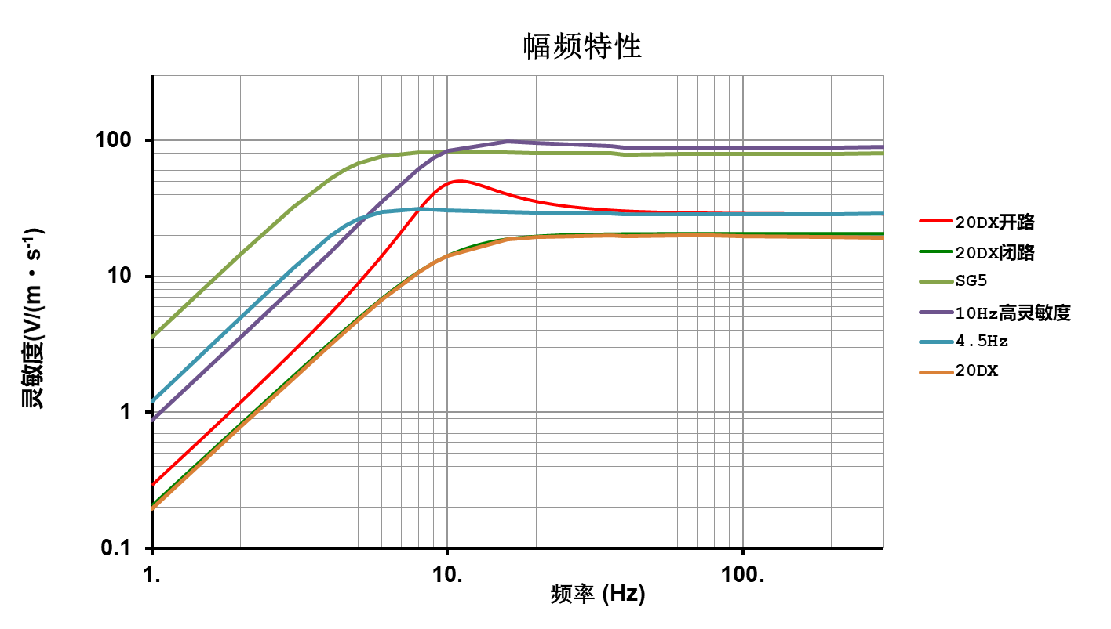
图 2不同参数检波器幅频特性比较

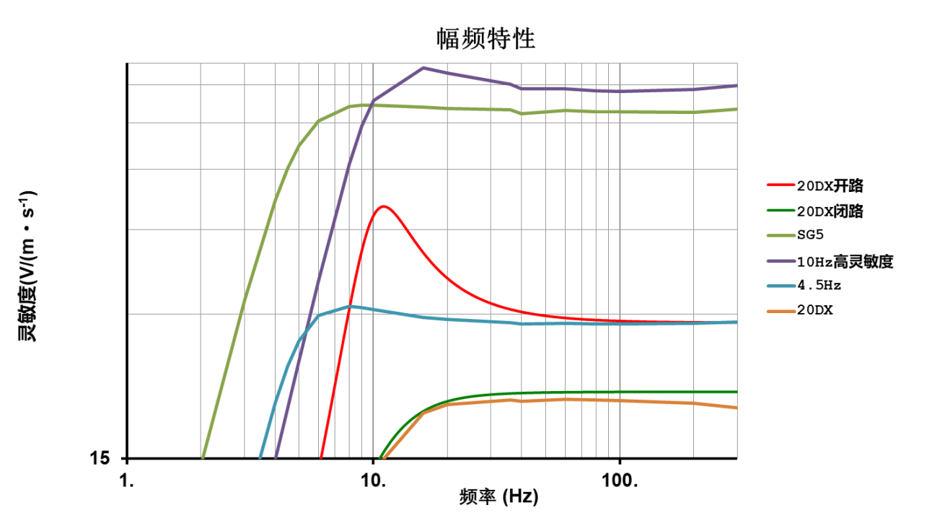

图 3图1局部放大图

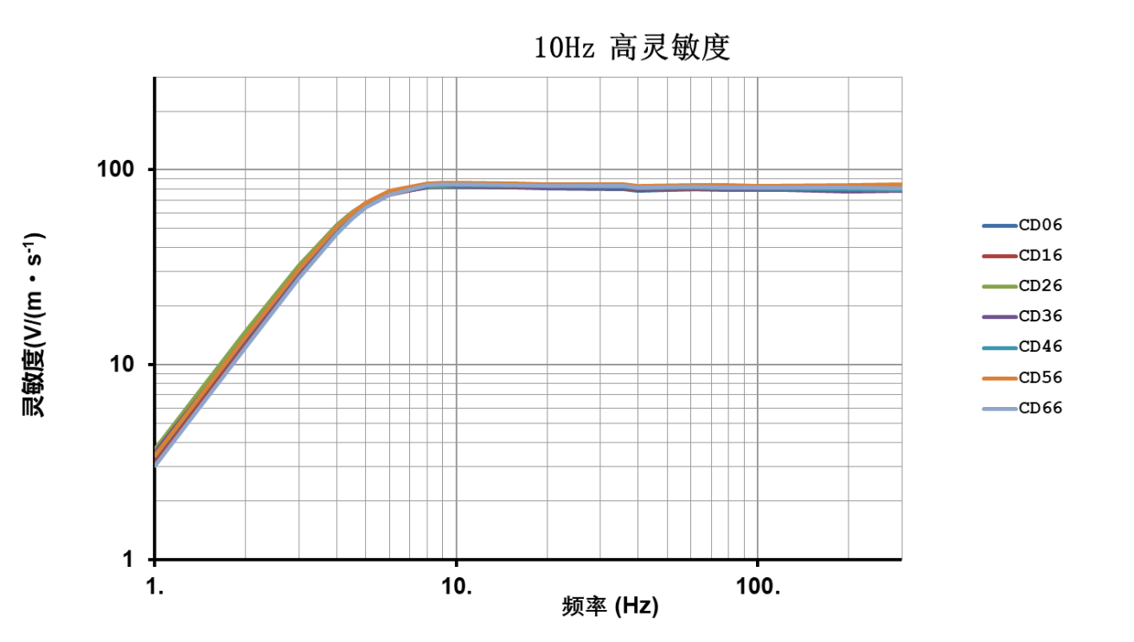

图 4 10Hz高灵敏度检波器幅频特性曲线

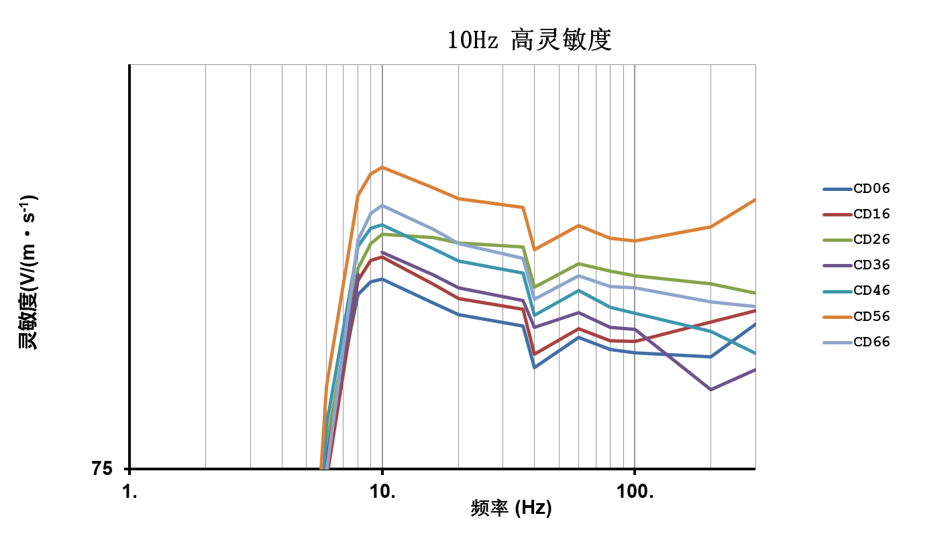
图 5 图3局部放大图
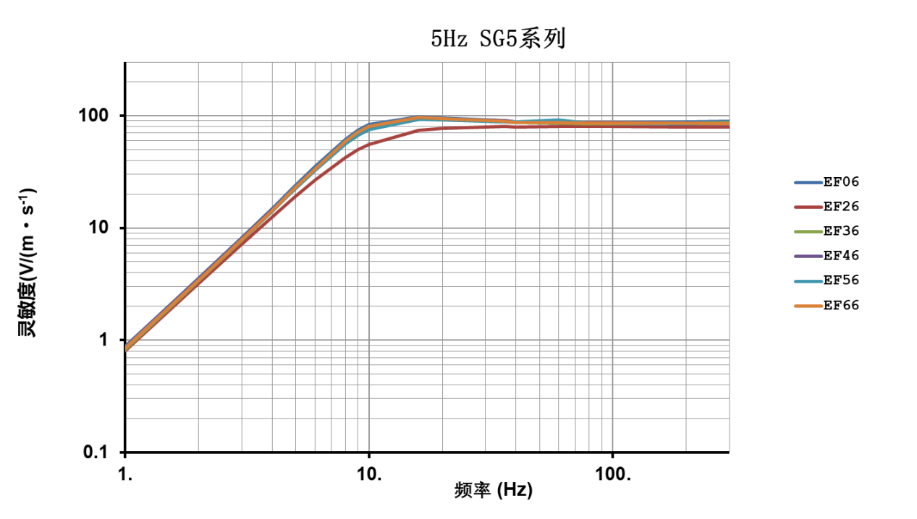
图 6 SG5检波器幅频特性曲线

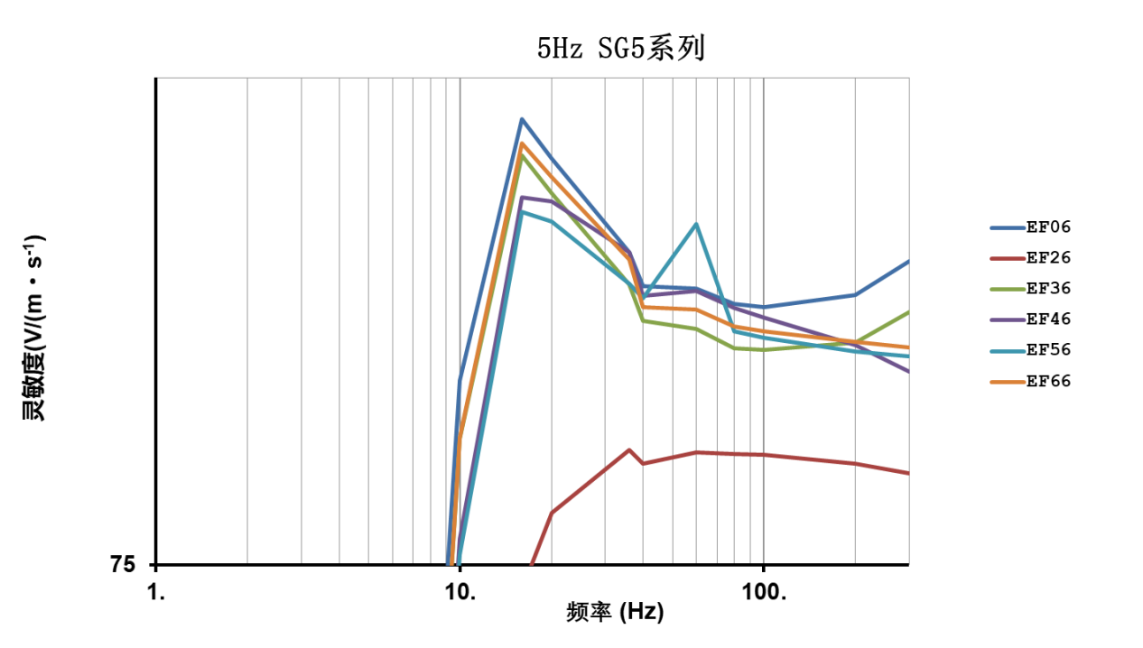

图 7 图5局部放大图
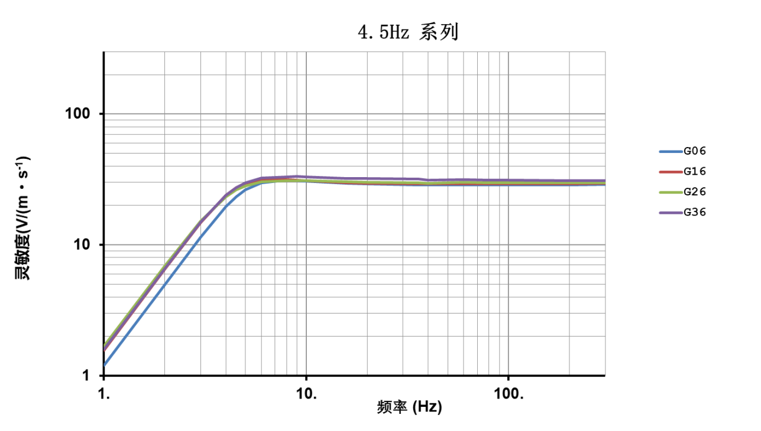
图 8 4.5Hz检波器幅频特性曲线

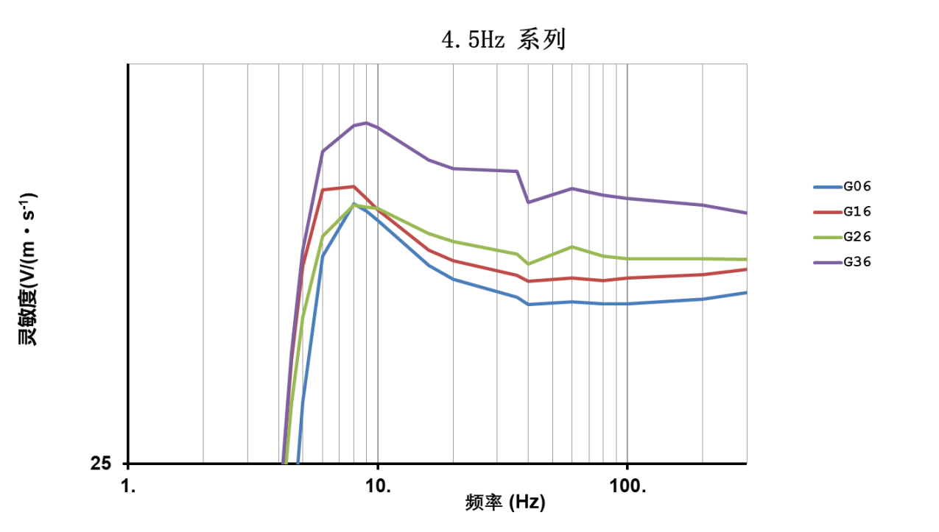

图 9 图7局部放大图
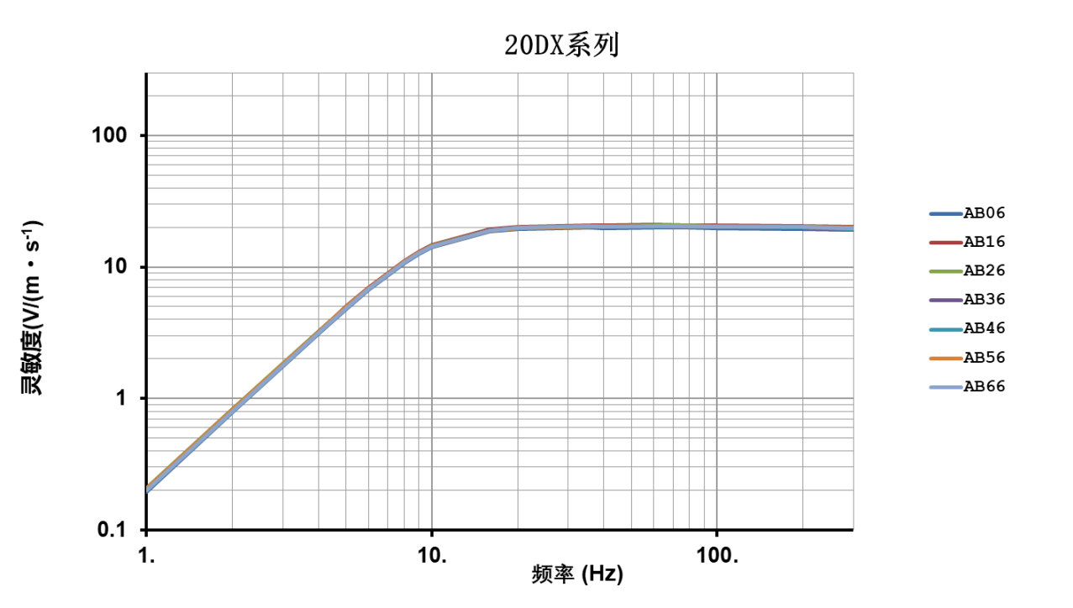
图 10 20DX检波器幅频特性曲线

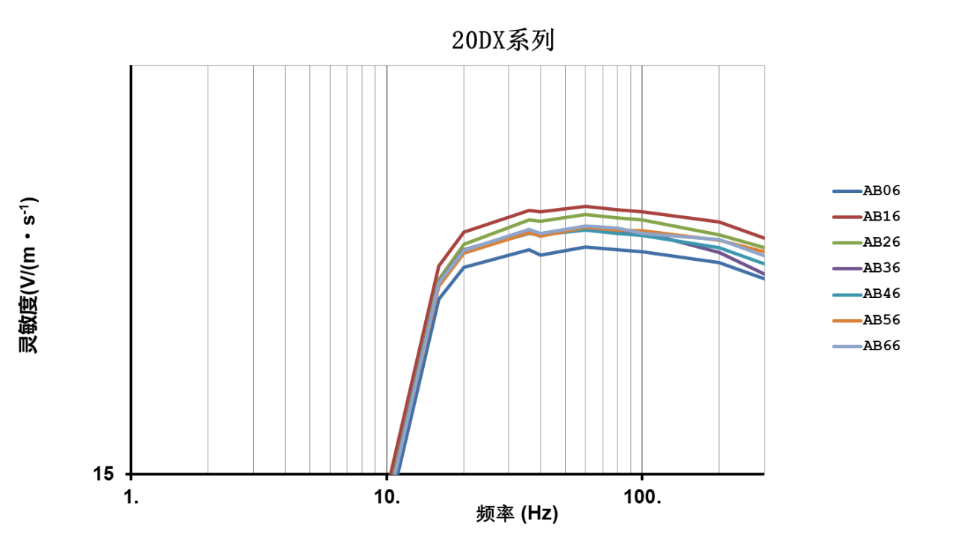
图 11 图9局部放大图

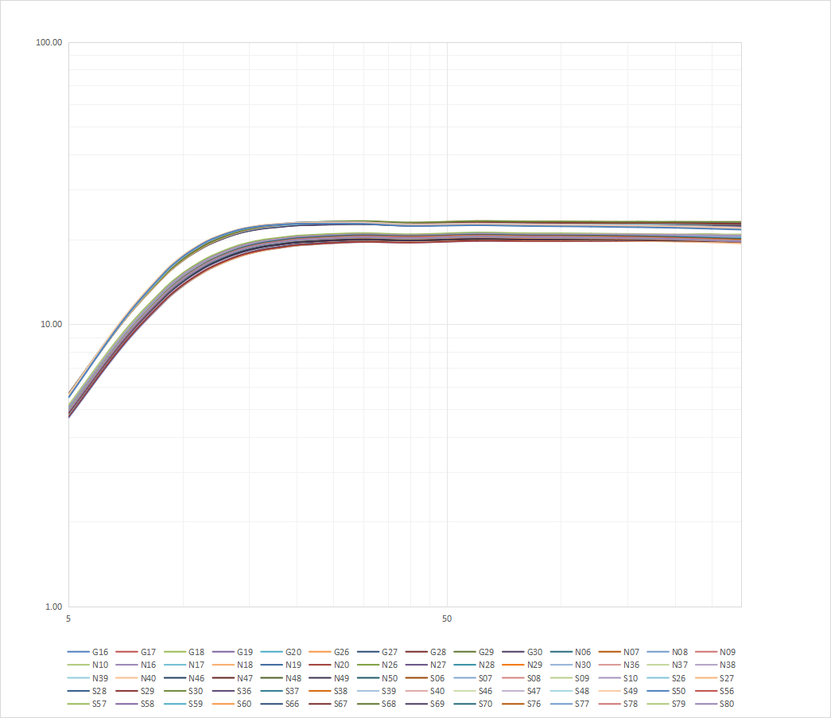
图 12 往年测试结果1

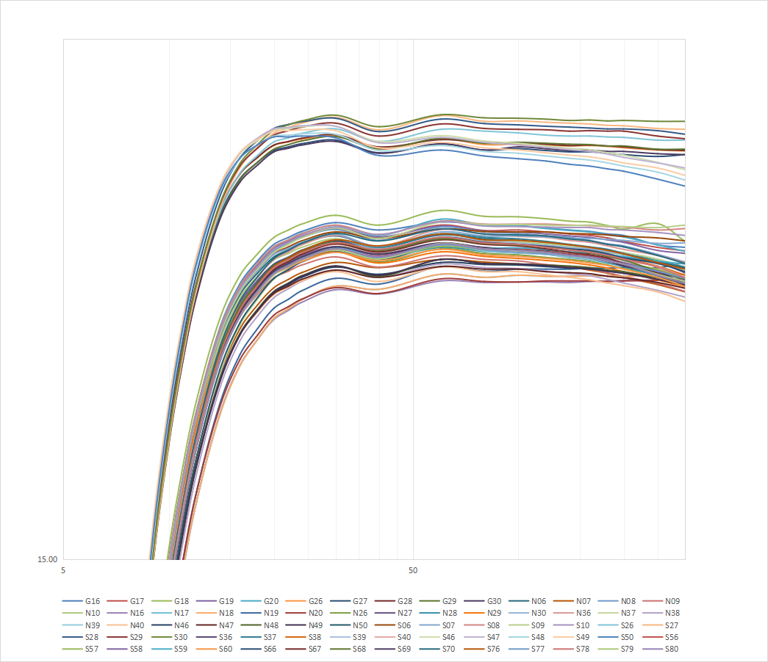
图 13 图11局部放大图

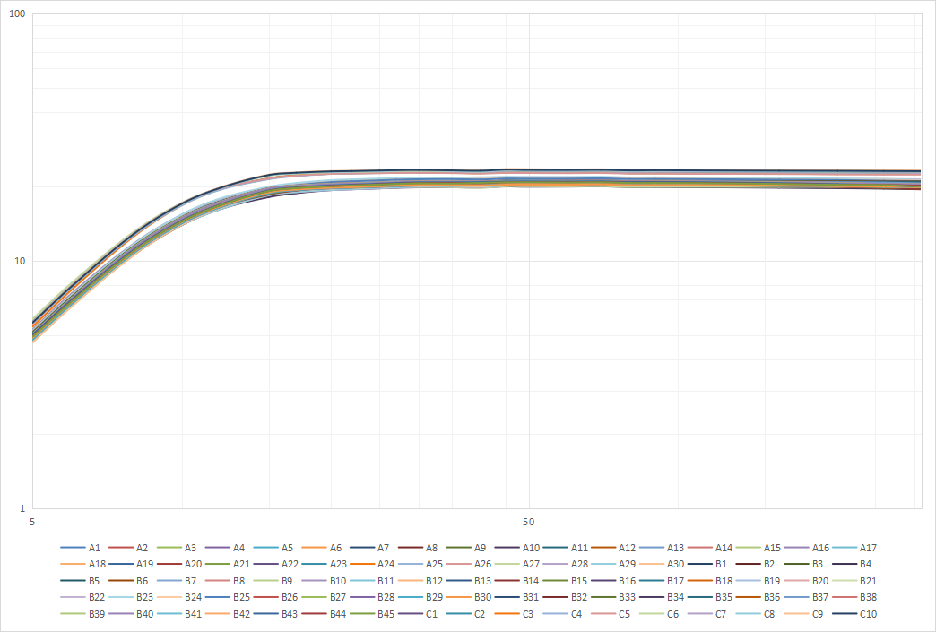
图 14 往年测试结果2

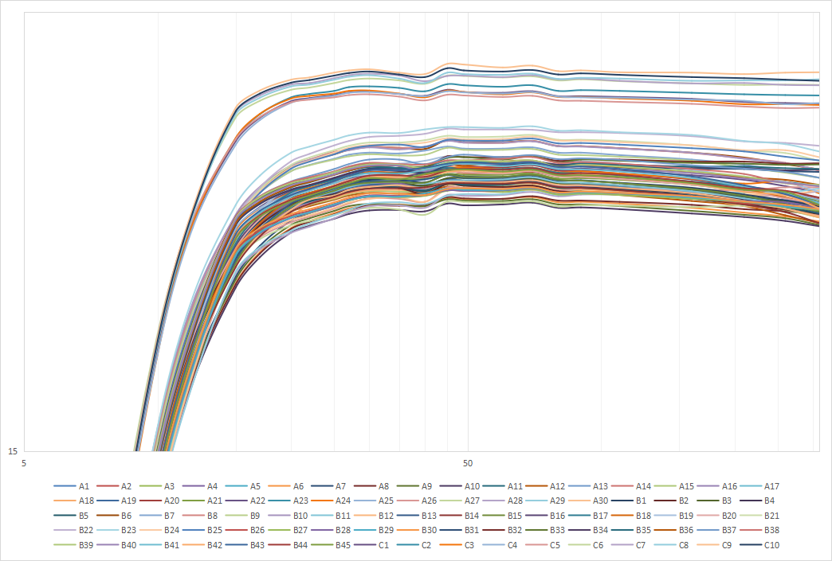
图 15 图13局部放大图

编号 | 1 | 2 | 3 | 4 | 4.5 | 5 | 6 | 8 | 9 | 10 | 16 | 20 | 36 | 40 | 60 | 80 | 100 | 200 | 300
CD06 | 3.5537 | 14.4417 | 32.0151 | 51.8457 | 60.3884 | 67.2074 | 75.7437 | 81.1429 | 81.6034 | 81.6889 | 80.8243 | 80.4082 | 79.983 | 78.5052 | 79.5925 | 79.1512 | 79.0311 | 78.893 | 80.0575
CD16 | 3.1705 | 12.8973 | 28.9697 | 48.2516 | 57.1627 | 64.5924 | 74.615 | 81.6481 | 82.4057 | 82.5196 | 81.4953 | 80.994 | 80.5884 | 78.9866 | 79.8985 | 79.4713 | 79.4289 | 80.1449 | 80.5512
CD26 | 3.6933 | 14.8559 | 32.5395 | 52.0161 | 60.3453 | 67.0715 | 75.8055 | 82.1061 | 83.0261 | 83.3592 | 83.2356 | 83.0394 | 82.9042 | 81.4009 | 82.2756 | 81.9985 | 81.8216 | 81.5302 | 81.1877
CD36 | 3.5537 | 13.4383 | 30.0918 | 49.6422 | 58.4699 | 65.7446 | 75.303 | 81.8781 |  | 82.6943 | 81.8568 | 81.3768 | 80.9142 | 79.9498 | 80.4717 | 79.9372 | 79.8607 | 77.7353 | 78.4255
CD46 | 3.4 | 13.8227 | 30.894 | 50.7951 | 59.6851 | 66.9869 | 76.4944 | 82.9082 | 83.5977 | 83.7161 | 82.8103 | 82.37 | 81.9239 | 80.3877 | 81.2696 | 80.6588 | 80.4435 | 79.7901 | 78.9964
CD56 | 3.4108 | 13.8376 | 30.9502 | 51.0752 | 60.1878 | 67.7657 | 77.8227 | 84.8324 | 85.6738 | 85.9278 | 85.1264 | 84.7064 | 84.3852 | 82.7863 | 83.6879 | 83.2181 | 83.1135 | 83.6519 | 84.6859
CD66 | 3.0199 | 12.3124 | 27.8082 | 46.8631 | 55.9709 | 63.8372 | 74.882 | 83.1394 | 84.1608 | 84.4492 | 83.5408 | 83.008 | 82.458 | 80.9687 | 81.8317 | 81.4282 | 81.384 | 80.868 | 80.6875
EF06 | 0.8727 | 3.5496 | 8.1674 | 14.898 | 19.1134 | 23.9057 | 35.1417 | 61.5119 | 73.8076 | 83.6196 | 97.5786 | 95.3408 | 90.2175 | 88.4041 | 88.2924 | 87.5144 | 87.3305 | 87.9491 | 89.7385
EF26 | 0.8043 | 3.1943 | 7.1459 | 12.5642 | 15.7613 | 19.2341 | 26.791 | 42.4647 | 49.5295 | 55.6495 | 73.9085 | 77.3237 | 80.2485 | 79.6011 | 80.1296 | 80.0613 | 80.0182 | 79.6024 | 79.167
EF36 | 0.8305 | 3.3821 | 7.7769 | 14.1876 | 18.2066 | 22.7731 | 33.5015 | 58.9165 | 71.0077 | 80.8153 | 95.5019 | 93.388 | 88.5153 | 86.611 | 86.1979 | 85.217 | 85.1529 | 85.5066 | 87.0939
EF46 | 0.8783 | 3.5258 | 8.045 | 14.5399 | 18.5433 | 23.0401 | 33.3446 | 56.5832 | 67.3242 | 76.1676 | 93.1928 | 92.9321 | 90.1894 | 87.9081 | 88.1761 | 87.2748 | 86.7959 | 85.4087 | 84.0657
EF56 | 0.8581 | 3.442 | 7.864 | 14.2254 | 18.1557 | 22.5695 | 32.7623 | 55.9469 | 66.676 | 75.4571 | 92.3725 | 91.8629 | 88.5542 | 87.7684 | 91.7244 | 86.0948 | 85.7732 | 85.0491 | 84.8374
EF66 | 0.8516 | 3.4291 | 7.8608 | 14.3163 | 18.3545 | 22.9422 | 33.6757 | 59.0229 | 71.037 | 80.8528 | 96.205 | 94.2934 | 89.8339 | 87.3437 | 87.2195 | 86.3308 | 86.1049 | 85.5635 | 85.2589
G06 | 1.1957 | 4.9645 | 11.4831 | 19.6378 | 23.3641 | 26.3305 | 29.7742 | 31.1127 | 30.9211 | 30.676 | 29.5389 | 29.1986 | 28.7607 | 28.5795 | 28.6514 | 28.5925 | 28.606 | 28.7117 | 28.8656
G16 | 1.5652 | 6.5191 | 14.8297 | 23.8914 | 27.2726 | 29.5261 | 31.4832 | 31.5666 | 31.2535 | 30.9575 | 29.9267 | 29.6504 | 29.2862 | 29.1502 | 29.2232 | 29.1652 | 29.2198 | 29.3057 | 29.4337
G26 | 1.6824 | 6.9136 | 15.2201 | 23.3697 | 26.2975 | 28.2823 | 30.2794 | 31.0735 | 31.0234 | 30.984 | 30.3367 | 30.1379 | 29.814 | 29.5736 | 30.0066 | 29.7623 | 29.6981 | 29.707 | 29.6885
G36 | 1.5857 | 6.5877 | 14.9121 | 23.9386 | 27.4387 | 29.925 | 32.5097 | 33.2179 | 33.2949 | 33.1643 | 32.2841 | 32.0391 | 31.9787 | 31.1424 | 31.517 | 31.3348 | 31.245 | 31.0677 | 30.8707
AB06 | 0.1958 | 0.7803 | 1.7536 | 3.0985 | 3.9031 | 4.7756 | 6.7032 | 10.7275 | 12.5719 | 14.1263 | 18.6681 | 19.421 | 19.8487 | 19.7149 | 19.918 | 19.8524 | 19.803 | 19.5372 | 19.1485
AB16 | 0.2069 | 0.8229 | 1.8445 | 3.2531 | 4.0891 | 4.9983 | 6.9871 | 11.1483 | 13.0361 | 14.6713 | 19.4551 | 20.2977 | 20.8522 | 20.8226 | 20.9571 | 20.8775 | 20.8214 | 20.5497 | 20.1458
AB26 | 0.2087 | 0.8273 | 1.8518 | 3.2553 | 4.0864 | 4.9872 | 6.9495 | 11.0219 | 12.853 | 14.4411 | 19.1337 | 19.9921 | 20.6016 | 20.5729 | 20.7502 | 20.6596 | 20.6014 | 20.2313 | 19.9115
AB36 | 0.2038 | 0.8089 | 1.8143 | 3.1996 | 4.0223 | 4.9168 | 6.8746 | 10.9631 | 12.8235 | 14.4184 | 19.0558 | 19.8483 | 20.3175 | 20.2239 | 20.4352 | 20.3374 | 20.3028 | 19.7951 | 19.2657
AB46 | 0.2001 | 0.7977 | 1.7896 | 3.162 | 3.977 | 4.8679 | 6.824 | 10.9193 | 12.7767 | 14.3832 | 19.0149 | 19.8224 | 20.2614 | 20.2278 | 20.3496 | 20.2582 | 20.2052 | 19.9095 | 19.5025
AB56 | 0.2053 | 0.8163 | 1.828 | 3.22 | 4.0431 | 4.9399 | 6.8962 | 10.9672 | 12.8077 | 14.3836 | 18.9729 | 19.7744 | 20.2713 | 20.1884 | 20.4214 | 20.3542 | 20.3369 | 20.0923 | 19.8062
AB66 | 0.1993 | 0.7937 | 1.7812 | 3.1405 | 3.9539 | 4.8342 | 6.7714 | 10.8509 | 12.7131 | 14.32 | 19.0449 | 19.8391 | 20.3617 | 20.2553 | 20.449 | 20.3978 | 20.253 | 20.1104 | 19.7006

表 1 往年测试数据1
编号 | 5 | 7 | 9 | 10 | 11 | 12 | 14 | 16 | 18 | 20 | 22 | 24 | 30 | 40 | 60 | 80 | 100 | 120 | 140 | 160 | 180 | 200 | 250 | 300
G16 | 4.99 | 9.14 | 13.16 | 14.87 | 16.22 | 17.31 | 18.82 | 19.66 | 20.11 | 20.43 | 20.57 | 20.69 | 20.87 | 20.72 | 20.88 | 20.83 | 20.81 | 20.76 | 20.72 | 20.69 | 20.64 | 20.61 | 20.42 | 20.37
G17 | 5.12 | 9.31 | 13.33 | 14.99 | 16.29 | 17.34 | 18.79 | 19.60 | 20.03 | 20.34 | 20.47 | 20.59 | 20.75 | 20.57 | 20.82 | 20.71 | 20.72 | 20.68 | 20.64 | 20.61 | 20.56 | 20.49 | 20.37 | 20.30
G18 | 5.17 | 9.41 | 13.46 | 15.14 | 16.46 | 17.52 | 18.99 | 19.82 | 20.25 | 20.57 | 20.72 | 20.84 | 21.02 | 20.82 | 21.12 | 21.00 | 20.99 | 20.95 | 20.90 | 20.88 | 20.81 | 20.74 | 20.85 | 20.49
G19 | 4.96 | 9.09 | 13.13 | 14.84 | 16.19 | 17.27 | 18.77 | 19.60 | 20.04 | 20.36 | 20.50 | 20.61 | 20.76 | 20.58 | 20.80 | 20.70 | 20.68 | 20.64 | 20.60 | 20.57 | 20.52 | 20.47 | 20.31 | 20.25
G20 | 5.10 | 9.28 | 13.30 | 14.96 | 16.28 | 17.34 | 18.80 | 19.63 | 20.06 | 20.38 | 20.52 | 20.65 | 20.81 | 20.61 | 20.94 | 20.82 | 20.80 | 20.75 | 20.71 | 20.68 | 20.62 | 20.58 | 20.42 | 20.29
G26 | 5.63 | 10.41 | 15.06 | 16.96 | 18.44 | 19.59 | 21.11 | 21.89 | 22.25 | 22.51 | 22.59 | 22.65 | 22.72 | 22.43 | 22.66 | 22.53 | 22.54 | 22.52 | 22.50 | 22.51 | 22.49 | 22.46 | 22.41 | 22.39
G27 | 5.57 | 10.32 | 14.95 | 16.85 | 18.33 | 19.49 | 21.01 | 21.79 | 22.15 | 22.40 | 22.48 | 22.55 | 22.63 | 22.35 | 22.54 | 22.41 | 22.44 | 22.40 | 22.37 | 22.37 | 22.34 | 22.31 | 22.27 | 22.31
G28 | 5.62 | 10.39 | 15.04 | 16.95 | 18.43 | 19.59 | 21.11 | 21.90 | 22.26 | 22.52 | 22.60 | 22.67 | 22.75 | 22.48 | 22.64 | 22.57 | 22.57 | 22.54 | 22.51 | 22.52 | 22.50 | 22.48 | 22.42 | 22.40
G29 | 5.57 | 10.28 | 14.88 | 16.77 | 18.25 | 19.42 | 20.96 | 21.77 | 22.15 | 22.43 | 22.53 | 22.61 | 22.71 | 22.44 | 22.67 | 22.56 | 22.58 | 22.56 | 22.54 | 22.53 | 22.50 | 22.50 | 22.43 | 22.43
G30 | 5.59 | 10.31 | 14.90 | 16.80 | 18.25 | 19.40 | 20.93 | 21.72 | 22.09 | 22.37 | 22.45 | 22.52 | 22.60 | 22.34 | 22.55 | 22.41 | 22.48 | 22.44 | 22.40 | 22.41 | 22.38 | 22.38 | 22.33 | 22.31
N06 | 5.06 | 9.24 | 13.24 | 14.88 | 16.20 | 17.23 | 18.64 | 19.45 | 19.87 | 20.18 | 20.32 | 20.44 | 20.60 | 20.38 | 20.62 | 20.54 | 20.51 | 20.45 | 20.40 | 20.36 | 20.30 | 20.23 | 20.12 | 19.87
N07 | 4.89 | 8.86 | 12.67 | 14.27 | 15.53 | 16.55 | 17.98 | 18.81 | 19.26 | 19.58 | 19.74 | 19.87 | 20.07 | 19.97 | 20.13 | 20.08 | 20.04 | 20.02 | 19.98 | 19.92 | 19.86 | 19.78 | 19.64 | 19.50
N08 | 4.88 | 8.91 | 12.94 | 14.65 | 16.01 | 17.12 | 18.63 | 19.52 | 19.97 | 20.30 | 20.45 | 20.57 | 20.73 | 20.51 | 20.78 | 20.68 | 20.65 | 20.60 | 20.57 | 20.51 | 20.44 | 20.40 | 20.23 | 20.08
N09 | 4.82 | 8.84 | 12.76 | 14.40 | 15.70 | 16.76 | 18.21 | 19.03 | 19.46 | 19.77 | 19.90 | 20.02 | 20.18 | 19.98 | 20.20 | 20.13 | 20.10 | 20.03 | 19.99 | 19.94 | 19.87 | 19.80 | 19.66 | 19.51
N10 | 4.96 | 9.09 | 13.08 | 14.74 | 16.06 | 17.12 | 18.57 | 19.39 | 19.81 | 20.12 | 20.25 | 20.37 | 20.54 | 20.35 | 20.56 | 20.49 | 20.48 | 20.42 | 20.37 | 20.34 | 20.27 | 20.23 | 20.11 | 19.90
N16 | 4.67 | 8.45 | 12.08 | 13.61 | 14.85 | 15.86 | 17.30 | 18.15 | 18.62 | 18.98 | 19.15 | 19.30 | 19.54 | 19.46 | 19.71 | 19.68 | 19.69 | 19.69 | 19.68 | 19.70 | 19.71 | 19.72 | 19.73 | 19.75
N17 | 4.76 | 8.55 | 12.15 | 13.66 | 14.87 | 15.87 | 17.28 | 18.14 | 18.62 | 19.00 | 19.18 | 19.35 | 19.61 | 19.55 | 19.84 | 19.78 | 19.82 | 19.80 | 19.80 | 19.81 | 19.81 | 19.80 | 19.84 | 19.84
N18 | 4.76 | 8.55 | 12.15 | 13.66 | 14.87 | 15.87 | 17.28 | 18.14 | 18.62 | 19.00 | 19.18 | 19.35 | 19.61 | 19.55 | 19.84 | 19.78 | 19.82 | 19.80 | 19.80 | 19.81 | 19.81 | 19.80 | 19.84 | 19.84
N19 | 4.70 | 8.52 | 12.20 | 13.74 | 15.00 | 16.02 | 17.47 | 18.34 | 18.82 | 19.19 | 19.36 | 19.52 | 19.76 | 19.65 | 19.99 | 19.90 | 19.94 | 19.94 | 19.94 | 19.96 | 19.96 | 19.97 | 19.97 | 20.07
N20 | 4.73 | 8.56 | 12.23 | 13.77 | 15.00 | 16.01 | 17.42 | 18.25 | 18.70 | 19.06 | 19.22 | 19.36 | 19.58 | 19.47 | 19.75 | 19.70 | 19.69 | 19.71 | 19.71 | 19.71 | 19.70 | 19.71 | 19.72 | 19.75
N26 | 5.00 | 9.12 | 13.04 | 14.66 | 15.94 | 16.97 | 18.37 | 19.16 | 19.57 | 19.89 | 20.01 | 20.13 | 20.29 | 20.08 | 20.34 | 20.25 | 20.22 | 20.17 | 20.13 | 20.09 | 20.02 | 19.95 | 19.83 | 19.62
N27 | 4.97 | 9.06 | 13.02 | 14.66 | 15.96 | 17.02 | 18.46 | 19.29 | 19.73 | 20.04 | 20.18 | 20.31 | 20.48 | 20.33 | 20.53 | 20.44 | 20.43 | 20.38 | 20.34 | 20.30 | 20.24 | 20.17 | 20.07 | 19.87
N28 | 4.92 | 8.99 | 12.93 | 14.58 | 15.88 | 16.93 | 18.37 | 19.19 | 19.61 | 19.92 | 20.05 | 20.18 | 20.34 | 20.16 | 20.37 | 20.29 | 20.26 | 20.23 | 20.17 | 20.13 | 20.06 | 19.99 | 19.81 | 19.67
N29 | 5.01 | 9.17 | 13.14 | 14.78 | 16.06 | 17.09 | 18.47 | 19.25 | 19.63 | 19.92 | 20.04 | 20.14 | 20.28 | 20.06 | 20.28 | 20.19 | 20.15 | 20.11 | 20.07 | 20.02 | 19.96 | 19.89 | 19.73 | 19.60
N30 | 4.90 | 8.95 | 12.87 | 14.52 | 15.84 | 16.90 | 18.38 | 19.23 | 19.68 | 20.03 | 20.17 | 20.31 | 20.49 | 20.32 | 20.57 | 20.49 | 20.45 | 20.41 | 20.37 | 20.34 | 20.28 | 20.23 | 20.06 | 19.94
N36 | 5.00 | 9.09 | 13.01 | 14.65 | 15.95 | 17.01 | 18.48 | 19.33 | 19.79 | 20.13 | 20.28 | 20.42 | 20.61 | 20.40 | 20.73 | 20.64 | 20.59 | 20.57 | 20.51 | 20.47 | 20.40 | 20.33 | 20.21 | 20.07
N37 | 4.99 | 8.97 | 12.71 | 14.28 | 15.52 | 16.55 | 18.00 | 18.88 | 19.37 | 19.75 | 19.95 | 20.11 | 20.38 | 20.32 | 20.57 | 20.51 | 20.50 | 20.45 | 20.40 | 20.37 | 20.31 | 20.27 | 20.14 | 19.97
N38 | 4.81 | 8.72 | 12.45 | 14.02 | 15.27 | 16.30 | 17.74 | 18.59 | 19.05 | 19.39 | 19.56 | 19.70 | 19.92 | 19.78 | 20.04 | 19.97 | 19.95 | 19.90 | 19.85 | 19.81 | 19.74 | 19.67 | 19.53 | 19.40
N39 | 4.80 | 8.83 | 12.78 | 14.45 | 15.79 | 16.87 | 18.36 | 19.19 | 19.63 | 19.96 | 20.09 | 20.20 | 20.35 | 20.11 | 20.41 | 20.30 | 20.26 | 20.23 | 20.18 | 20.14 | 20.08 | 20.01 | 19.91 | 19.78
N40 | 4.92 | 8.92 | 12.72 | 14.29 | 15.54 | 16.53 | 17.92 | 18.71 | 19.13 | 19.45 | 19.59 | 19.71 | 19.89 | 19.70 | 19.98 | 19.89 | 19.89 | 19.83 | 19.78 | 19.73 | 19.67 | 19.62 | 19.50 | 19.32
N46 | 4.88 | 8.87 | 12.65 | 14.24 | 15.48 | 16.46 | 17.90 | 18.72 | 19.16 | 19.49 | 19.64 | 19.78 | 19.98 | 19.84 | 20.07 | 20.03 | 20.02 | 19.99 | 19.96 | 19.94 | 19.90 | 19.86 | 19.78 | 19.66
N47 | 4.85 | 8.83 | 12.63 | 14.20 | 15.46 | 16.47 | 17.85 | 18.70 | 19.15 | 19.47 | 19.61 | 19.74 | 19.92 | 19.78 | 19.99 | 19.94 | 19.94 | 19.89 | 19.87 | 19.85 | 19.80 | 19.77 | 19.68 | 19.57
N48 | 4.84 | 8.80 | 12.58 | 14.15 | 15.42 | 16.45 | 17.87 | 18.72 | 19.18 | 19.51 | 19.67 | 19.81 | 20.00 | 19.80 | 20.13 | 20.05 | 20.04 | 20.02 | 20.00 | 19.97 | 19.92 | 19.89 | 19.77 | 19.69
N49 | 4.83 | 8.77 | 12.55 | 14.13 | 15.40 | 16.43 | 17.86 | 18.70 | 19.16 | 19.50 | 19.66 | 19.80 | 20.00 | 19.82 | 20.13 | 20.05 | 20.04 | 20.01 | 19.97 | 19.95 | 19.90 | 19.86 | 19.74 | 19.62
N50 | 4.84 | 8.81 | 12.63 | 14.24 | 15.53 | 16.57 | 18.06 | 18.92 | 19.40 | 19.76 | 19.93 | 20.08 | 20.28 | 20.12 | 20.43 | 20.35 | 20.32 | 20.31 | 20.28 | 20.25 | 20.21 | 20.17 | 20.08 | 19.96
S06 | 5.07 | 9.23 | 13.22 | 14.88 | 16.18 | 17.22 | 18.68 | 19.49 | 19.92 | 20.24 | 20.38 | 20.50 | 20.68 | 20.55 | 20.74 | 20.69 | 20.68 | 20.68 | 20.65 | 20.64 | 20.62 | 20.59 | 20.56 | 20.50
S07 | 5.00 | 9.15 | 13.17 | 14.84 | 16.17 | 17.23 | 18.68 | 19.49 | 19.92 | 20.23 | 20.35 | 20.47 | 20.63 | 20.38 | 20.68 | 20.60 | 20.60 | 20.58 | 20.55 | 20.55 | 20.53 | 20.51 | 20.45 | 20.46
S08 | 5.10 | 9.27 | 13.28 | 14.96 | 16.26 | 17.33 | 18.79 | 19.61 | 20.06 | 20.38 | 20.52 | 20.64 | 20.82 | 20.63 | 20.90 | 20.84 | 20.84 | 20.84 | 20.82 | 20.81 | 20.79 | 20.78 | 20.72 | 20.75
S09 | 5.15 | 9.32 | 13.28 | 14.92 | 16.21 | 17.25 | 18.69 | 19.51 | 19.95 | 20.27 | 20.43 | 20.56 | 20.76 | 20.55 | 20.88 | 20.83 | 20.83 | 20.82 | 20.81 | 20.82 | 20.80 | 20.79 | 20.77 | 20.82
S10 | 5.09 | 9.24 | 13.25 | 14.91 | 16.22 | 17.28 | 18.74 | 19.56 | 19.99 | 20.33 | 20.47 | 20.60 | 20.78 | 20.63 | 20.89 | 20.80 | 20.79 | 20.78 | 20.77 | 20.77 | 20.73 | 20.72 | 20.67 | 20.61
S26 | 5.66 | 10.42 | 15.01 | 16.91 | 18.38 | 19.54 | 21.08 | 21.91 | 22.30 | 22.59 | 22.68 | 22.78 | 22.88 | 22.60 | 22.87 | 22.83 | 22.79 | 22.74 | 22.72 | 22.72 | 22.70 | 22.69 | 22.63 | 22.63
S27 | 5.60 | 10.30 | 14.90 | 16.82 | 18.32 | 19.52 | 21.15 | 22.03 | 22.48 | 22.78 | 22.91 | 23.01 | 23.14 | 22.86 | 23.18 | 23.05 | 23.06 | 23.03 | 23.01 | 22.99 | 22.96 | 22.95 | 22.89 | 22.87
S28 | 5.67 | 10.49 | 15.18 | 17.13 | 18.64 | 19.83 | 21.41 | 22.24 | 22.63 | 22.89 | 22.98 | 23.04 | 23.12 | 22.82 | 23.10 | 23.00 | 22.97 | 22.94 | 22.92 | 22.90 | 22.88 | 22.88 | 22.84 | 22.76
S29 | 5.67 | 10.45 | 15.09 | 17.00 | 18.50 | 19.67 | 21.23 | 22.07 | 22.46 | 22.74 | 22.84 | 22.92 | 23.01 | 22.72 | 22.99 | 22.89 | 22.87 | 22.86 | 22.83 | 22.84 | 22.83 | 22.83 | 22.72 | 22.66
S30 | 5.65 | 10.39 | 15.01 | 16.93 | 18.43 | 19.63 | 21.25 | 22.12 | 22.54 | 22.85 | 22.97 | 23.06 | 23.19 | 22.93 | 23.20 | 23.13 | 23.12 | 23.10 | 23.07 | 23.08 | 23.06 | 23.07 | 23.05 | 23.05
S36 | 4.92 | 8.95 | 12.86 | 14.49 | 15.78 | 16.83 | 18.29 | 19.14 | 19.57 | 19.91 | 20.05 | 20.19 | 20.38 | 20.23 | 20.44 | 20.37 | 20.32 | 20.28 | 20.21 | 20.16 | 20.09 | 20.01 | 19.84 | 19.64
S37 | 5.02 | 9.06 | 12.91 | 14.50 | 15.77 | 16.81 | 18.26 | 19.11 | 19.60 | 19.92 | 20.11 | 20.27 | 20.50 | 20.36 | 20.64 | 20.57 | 20.54 | 20.49 | 20.43 | 20.38 | 20.33 | 20.25 | 20.10 | 19.98
S38 | 4.93 | 8.96 | 12.81 | 14.42 | 15.71 | 16.77 | 18.23 | 19.10 | 19.56 | 19.91 | 20.09 | 20.24 | 20.45 | 20.31 | 20.56 | 20.48 | 20.44 | 20.39 | 20.33 | 20.29 | 20.22 | 20.15 | 20.00 | 19.82
S39 | 5.01 | 9.11 | 13.02 | 14.62 | 15.92 | 16.96 | 18.42 | 19.24 | 19.69 | 20.03 | 20.18 | 20.31 | 20.50 | 20.34 | 20.58 | 20.50 | 20.46 | 20.40 | 20.32 | 20.27 | 20.19 | 20.09 | 19.87 | 19.66
S40 | 4.93 | 8.95 | 12.82 | 14.43 | 15.72 | 16.77 | 18.23 | 19.09 | 19.56 | 19.91 | 20.07 | 20.22 | 20.43 | 20.27 | 20.54 | 20.46 | 20.42 | 20.38 | 20.31 | 20.27 | 20.19 | 20.11 | 19.99 | 19.78
S46 | 5.63 | 10.54 | 15.39 | 17.37 | 18.89 | 20.08 | 21.58 | 22.33 | 22.63 | 22.85 | 22.89 | 22.93 | 22.94 | 22.60 | 22.73 | 22.61 | 22.56 | 22.50 | 22.45 | 22.42 | 22.35 | 22.30 | 22.14 | 21.98
S47 | 5.54 | 10.40 | 15.27 | 17.28 | 18.83 | 20.06 | 21.60 | 22.35 | 22.68 | 22.88 | 22.91 | 22.95 | 22.94 | 22.57 | 22.69 | 22.58 | 22.52 | 22.47 | 22.42 | 22.38 | 22.32 | 22.25 | 22.13 | 22.02
S48 | 5.51 | 10.38 | 15.21 | 17.23 | 18.77 | 19.97 | 21.49 | 22.22 | 22.53 | 22.72 | 22.74 | 22.77 | 22.76 | 22.40 | 22.51 | 22.38 | 22.34 | 22.28 | 22.23 | 22.19 | 22.13 | 22.06 | 21.93 | 21.76
S49 | 5.62 | 10.57 | 15.48 | 17.48 | 19.00 | 20.19 | 21.64 | 22.36 | 22.65 | 22.83 | 22.84 | 22.86 | 22.84 | 22.46 | 22.58 | 22.46 | 22.41 | 22.35 | 22.30 | 22.26 | 22.20 | 22.13 | 22.02 | 21.86
S50 | 5.51 | 10.41 | 15.30 | 17.31 | 18.86 | 20.05 | 21.53 | 22.24 | 22.53 | 22.70 | 22.70 | 22.72 | 22.68 | 22.29 | 22.41 | 22.28 | 22.22 | 22.17 | 22.10 | 22.06 | 22.00 | 21.95 | 21.78 | 21.63
S56 | 4.84 | 8.83 | 12.71 | 14.36 | 15.66 | 16.73 | 18.21 | 19.07 | 19.54 | 19.87 | 20.03 | 20.16 | 20.35 | 20.20 | 20.43 | 20.36 | 20.34 | 20.29 | 20.24 | 20.20 | 20.14 | 20.06 | 19.93 | 19.75
S57 | 4.85 | 8.89 | 12.83 | 14.49 | 15.80 | 16.86 | 18.33 | 19.17 | 19.61 | 19.92 | 20.06 | 20.19 | 20.36 | 20.17 | 20.39 | 20.32 | 20.30 | 20.25 | 20.21 | 20.17 | 20.11 | 20.05 | 19.94 | 19.77
S58 | 4.82 | 8.83 | 12.75 | 14.40 | 15.72 | 16.81 | 18.29 | 19.15 | 19.61 | 19.93 | 20.08 | 20.21 | 20.38 | 20.19 | 20.45 | 20.34 | 20.31 | 20.27 | 20.22 | 20.18 | 20.13 | 20.06 | 19.90 | 19.72
S59 | 4.83 | 8.84 | 12.72 | 14.31 | 15.67 | 16.74 | 18.22 | 19.08 | 19.55 | 19.89 | 20.04 | 20.17 | 20.37 | 20.18 | 20.45 | 20.36 | 20.36 | 20.33 | 20.28 | 20.27 | 20.23 | 20.19 | 20.10 | 20.04
S60 | 4.85 | 8.86 | 12.75 | 14.39 | 15.69 | 16.76 | 18.22 | 19.05 | 19.51 | 19.83 | 19.97 | 20.09 | 20.27 | 20.11 | 20.33 | 20.22 | 20.19 | 20.15 | 20.11 | 20.06 | 20.01 | 19.94 | 19.78 | 19.60
S66 | 4.87 | 8.90 | 12.83 | 14.48 | 15.80 | 16.87 | 18.37 | 19.23 | 19.69 | 20.03 | 20.17 | 20.31 | 20.50 | 20.31 | 20.57 | 20.47 | 20.43 | 20.39 | 20.34 | 20.31 | 20.24 | 20.16 | 20.05 | 19.89
S67 | 4.87 | 8.86 | 12.73 | 14.36 | 15.66 | 16.73 | 18.23 | 19.10 | 19.57 | 19.93 | 20.09 | 20.23 | 20.44 | 20.28 | 20.52 | 20.43 | 20.40 | 20.34 | 20.27 | 20.22 | 20.16 | 20.05 | 19.86 | 19.65
S68 | 4.97 | 9.03 | 12.95 | 14.59 | 15.88 | 16.94 | 18.39 | 19.23 | 19.67 | 20.01 | 20.15 | 20.29 | 20.47 | 20.31 | 20.54 | 20.45 | 20.42 | 20.37 | 20.32 | 20.26 | 20.19 | 20.12 | 19.90 | 19.74
S69 | 4.95 | 9.01 | 12.89 | 14.50 | 15.79 | 16.83 | 18.28 | 19.12 | 19.57 | 19.90 | 20.05 | 20.18 | 20.38 | 20.24 | 20.46 | 20.36 | 20.32 | 20.28 | 20.22 | 20.17 | 20.10 | 20.00 | 19.89 | 19.65
S70 | 4.94 | 8.98 | 12.90 | 14.56 | 15.87 | 16.95 | 18.46 | 19.33 | 19.80 | 20.15 | 20.31 | 20.45 | 20.65 | 20.50 | 20.74 | 20.64 | 20.62 | 20.60 | 20.54 | 20.50 | 20.43 | 20.38 | 20.21 | 20.05
S76 | 4.95 | 8.98 | 12.85 | 14.48 | 15.77 | 16.82 | 18.31 | 19.17 | 19.64 | 19.99 | 20.16 | 20.30 | 20.52 | 20.40 | 20.64 | 20.52 | 20.51 | 20.47 | 20.42 | 20.37 | 20.31 | 20.24 | 20.07 | 19.94
S77 | 4.94 | 8.97 | 12.83 | 14.44 | 15.72 | 16.76 | 18.22 | 19.05 | 19.50 | 19.84 | 19.99 | 20.13 | 20.33 | 20.16 | 20.42 | 20.32 | 20.27 | 20.24 | 20.20 | 20.16 | 20.10 | 20.04 | 19.90 | 19.76
S78 | 4.95 | 8.99 | 12.87 | 14.50 | 15.80 | 16.85 | 18.32 | 19.16 | 19.63 | 19.97 | 20.12 | 20.26 | 20.46 | 20.33 | 20.57 | 20.46 | 20.43 | 20.37 | 20.32 | 20.27 | 20.21 | 20.14 | 19.98 | 19.77
S79 | 4.95 | 8.98 | 12.83 | 14.43 | 15.72 | 16.75 | 18.20 | 19.04 | 19.49 | 19.83 | 19.99 | 20.13 | 20.32 | 20.14 | 20.45 | 20.34 | 20.31 | 20.27 | 20.21 | 20.17 | 20.10 | 20.04 | 19.84 | 19.70
S80 | 4.92 | 8.93 | 12.78 | 14.40 | 15.69 | 16.73 | 18.20 | 19.04 | 19.51 | 19.85 | 20.00 | 20.13 | 20.34 | 20.18 | 20.44 | 20.34 | 20.31 | 20.27 | 20.21 | 20.17 | 20.10 | 20.04 | 19.82 | 19.66

表 2 往年测试数据2
编号 | 5 | 6 | 8 | 10 | 12 | 15 | 17 | 20 | 22 | 25 | 27 | 30 | 35 | 40 | 45 | 49 | 60 | 70 | 80 | 90 | 110 | 160 | 210 | 260 | 310
A1 | 5 | 6.99 | 11.23 | 14.79 | 17.13 | 18.99 | 19.6 | 20.07 | 20.2 | 20.32 | 20.41 | 20.46 | 20.43 | 20.43 | 20.56 | 20.54 | 20.51 | 20.55 | 20.43 | 20.42 | 20.37 | 20.25 | 20.14 | 20.04 | 19.84
A2 | 5.1 | 7.11 | 11.36 | 14.93 | 17.27 | 19.12 | 19.75 | 20.24 | 20.36 | 20.5 | 20.59 | 20.66 | 20.64 | 20.61 | 20.77 | 20.73 | 20.72 | 20.76 | 20.65 | 20.65 | 20.61 | 20.48 | 20.36 | 20.23 | 20.03
A3 | 4.99 | 6.96 | 11.16 | 14.68 | 17.04 | 18.89 | 19.52 | 20.03 | 20.16 | 20.32 | 20.4 | 20.47 | 20.44 | 20.39 | 20.58 | 20.53 | 20.53 | 20.58 | 20.45 | 20.45 | 20.4 | 20.28 | 20.19 | 20 | 19.82
A4 | 5 | 6.96 | 11.16 | 14.68 | 17.04 | 18.91 | 19.54 | 20.05 | 20.19 | 20.33 | 20.43 | 20.48 | 20.48 | 20.44 | 20.59 | 20.55 | 20.56 | 20.6 | 20.49 | 20.49 | 20.43 | 20.31 | 20.15 | 20 | 19.87
A5 | 5.07 | 7.07 | 11.29 | 14.8 | 17.1 | 18.91 | 19.5 | 19.98 | 20.11 | 20.24 | 20.34 | 20.39 | 20.38 | 20.31 | 20.51 | 20.48 | 20.46 | 20.49 | 20.37 | 20.36 | 20.3 | 20.19 | 20.04 | 19.88 | 19.7
A6 | 4.75 | 6.61 | 10.6 | 13.98 | 16.31 | 18.24 | 18.91 | 19.45 | 19.61 | 19.79 | 19.9 | 19.97 | 19.99 | 19.95 | 20.14 | 20.1 | 20.12 | 20.16 | 20.04 | 20.05 | 20.01 | 19.91 | 19.8 | 19.71 | 19.6
A7 | 4.82 | 6.71 | 10.71 | 14.13 | 16.44 | 18.38 | 19.05 | 19.62 | 19.79 | 19.97 | 20.09 | 20.17 | 20.17 | 20.2 | 20.34 | 20.32 | 20.3 | 20.36 | 20.23 | 20.24 | 20.22 | 20.12 | 19.99 | 19.96 | 19.86
A8 | 4.87 | 6.75 | 10.74 | 14.08 | 16.35 | 18.22 | 18.88 | 19.43 | 19.59 | 19.76 | 19.87 | 19.96 | 19.96 | 19.98 | 20.16 | 20.13 | 20.12 | 20.18 | 20.08 | 20.08 | 20.05 | 19.98 | 19.88 | 19.83 | 19.75
A9 | 4.71 | 6.6 | 10.62 | 14.07 | 16.4 | 18.32 | 18.98 | 19.52 | 19.67 | 19.84 | 19.95 | 20 | 19.98 | 19.95 | 20.11 | 20.08 | 20.07 | 20.11 | 19.99 | 19.99 | 19.95 | 19.84 | 19.75 | 19.67 | 19.52
A10 | 4.76 | 6.63 | 10.61 | 13.98 | 16.25 | 18.15 | 18.8 | 19.35 | 19.5 | 19.66 | 19.77 | 19.85 | 19.86 | 19.83 | 20.01 | 19.97 | 19.99 | 20.03 | 19.91 | 19.92 | 19.88 | 19.78 | 19.7 | 19.61 | 19.49
A11 | 5.05 | 7.01 | 11.14 | 14.58 | 16.85 | 18.71 | 19.37 | 19.9 | 20.05 | 20.22 | 20.33 | 20.4 | 20.41 | 20.34 | 20.58 | 20.55 | 20.54 | 20.58 | 20.45 | 20.44 | 20.39 | 20.27 | 20.15 | 20 | 19.83
A12 | 4.93 | 6.86 | 10.98 | 14.44 | 16.74 | 18.63 | 19.29 | 19.82 | 19.95 | 20.1 | 20.2 | 20.26 | 20.24 | 20.27 | 20.41 | 20.37 | 20.35 | 20.39 | 20.28 | 20.28 | 20.21 | 20.07 | 19.95 | 19.74 | 19.56
A13 | 4.92 | 6.84 | 10.9 | 14.34 | 16.68 | 18.61 | 19.3 | 19.87 | 20.04 | 20.22 | 20.33 | 20.42 | 20.43 | 20.43 | 20.59 | 20.55 | 20.55 | 20.6 | 20.49 | 20.48 | 20.42 | 20.28 | 20.13 | 19.98 | 19.75
A14 | 4.86 | 6.78 | 10.88 | 14.37 | 16.74 | 18.71 | 19.38 | 19.91 | 20.07 | 20.24 | 20.34 | 20.42 | 20.42 | 20.39 | 20.57 | 20.54 | 20.53 | 20.59 | 20.45 | 20.44 | 20.38 | 20.24 | 20.1 | 19.94 | 19.76
A15 | 4.92 | 6.85 | 10.99 | 14.43 | 16.74 | 18.64 | 19.29 | 19.82 | 19.98 | 20.12 | 20.23 | 20.3 | 20.29 | 20.3 | 20.46 | 20.43 | 20.41 | 20.44 | 20.3 | 20.3 | 20.25 | 20.14 | 19.98 | 19.86 | 19.69
A16 | 5 | 6.95 | 11.07 | 14.51 | 16.82 | 18.69 | 19.34 | 19.87 | 20.03 | 20.18 | 20.29 | 20.37 | 20.38 | 20.36 | 20.52 | 20.52 | 20.5 | 20.55 | 20.43 | 20.42 | 20.37 | 20.25 | 20.09 | 19.98 | 19.74
A17 | 4.85 | 6.76 | 10.8 | 14.25 | 16.64 | 18.65 | 19.36 | 19.97 | 20.15 | 20.35 | 20.47 | 20.56 | 20.58 | 20.58 | 20.79 | 20.74 | 20.75 | 20.8 | 20.68 | 20.68 | 20.63 | 20.51 | 20.38 | 20.28 | 20.15
A18 | 4.93 | 6.87 | 10.97 | 14.45 | 16.76 | 18.67 | 19.31 | 19.71 | 19.99 | 20.14 | 20.25 | 20.32 | 20.33 | 20.31 | 20.47 | 20.44 | 20.45 | 20.48 | 20.36 | 20.34 | 20.3 | 20.17 | 19.96 | 19.88 | 19.69
A19 | 4.78 | 6.66 | 10.76 | 14.29 | 16.72 | 18.7 | 19.39 | 19.95 | 20.11 | 20.27 | 20.38 | 20.45 | 20.44 | 20.44 | 20.59 | 20.55 | 20.56 | 20.59 | 20.48 | 20.48 | 20.43 | 20.33 | 20.17 | 20.09 | 19.98
A20 | 4.9 | 6.83 | 10.99 | 14.56 | 17.01 | 19.01 | 19.7 | 20.25 | 20.42 | 20.58 | 20.68 | 20.76 | 20.74 | 20.79 | 20.94 | 20.9 | 20.87 | 20.92 | 20.79 | 20.79 | 20.72 | 20.58 | 20.41 | 20.3 | 20.11
A21 | 4.95 | 6.91 | 11.07 | 14.56 | 16.97 | 19.29 | 19.77 | 20.13 | 20.23 | 20.4 | 20.51 | 20.6 | 20.58 | 20.6 | 20.71 | 20.69 | 20.69 | 20.72 | 20.6 | 20.61 | 20.57 | 20.45 | 20.3 | 20.22 | 20.08
A22 | 4.91 | 6.86 | 11.03 | 14.6 | 17.02 | 19.41 | 19.93 | 20.3 | 20.43 | 20.6 | 20.72 | 20.82 | 20.83 | 20.77 | 20.9 | 20.96 | 20.91 | 20.94 | 20.82 | 20.84 | 20.79 | 20.68 | 20.57 | 20.42 | 20.27
A23 | 5.03 | 7.02 | 11.28 | 14.87 | 17.28 | 19.62 | 20.11 | 20.44 | 20.55 | 20.7 | 20.81 | 20.89 | 20.86 | 20.88 | 21.03 | 21.02 | 21 | 21.02 | 20.9 | 20.92 | 20.87 | 20.77 | 20.62 | 20.52 | 20.42
A24 | 4.86 | 6.81 | 10.97 | 14.55 | 16.99 | 19.39 | 19.9 | 20.27 | 20.38 | 20.54 | 20.66 | 20.75 | 20.74 | 20.75 | 20.86 | 20.87 | 20.83 | 20.86 | 20.75 | 20.77 | 20.72 | 20.6 | 20.48 | 20.52 | 20.25
A25 | 5.01 | 6.98 | 11.19 | 14.73 | 17.12 | 19.43 | 19.91 | 20.24 | 20.35 | 20.5 | 20.6 | 20.68 | 20.65 | 20.63 | 20.79 | 20.8 | 20.75 | 20.78 | 20.66 | 20.66 | 20.61 | 20.5 | 20.35 | 20.27 | 20.1
A26 | 4.82 | 6.71 | 10.71 | 14.09 | 16.4 | 18.71 | 19.24 | 19.58 | 19.71 | 19.89 | 20.01 | 20.13 | 20.12 | 20.05 | 20.39 | 20.38 | 20.37 | 20.42 | 20.32 | 20.37 | 20.35 | 20.34 | 20.32 | 20.39 | 20.39
A27 | 4.69 | 6.57 | 10.64 | 14.12 | 16.48 | 18.75 | 19.2 | 19.51 | 19.61 | 19.75 | 19.84 | 19.91 | 19.87 | 19.75 | 20.06 | 20.05 | 20.03 | 20.06 | 19.94 | 19.97 | 19.96 | 19.93 | 19.96 | 19.93 | 19.99
A28 | 4.97 | 6.88 | 10.83 | 14.06 | 16.24 | 18.46 | 18.97 | 19.34 | 19.48 | 19.67 | 19.81 | 19.95 | 19.97 | 19.91 | 20.21 | 20.19 | 20.21 | 20.28 | 20.18 | 20.22 | 20.22 | 20.2 | 20.2 | 20.2 | 20.3
A29 | 4.91 | 6.79 | 10.73 | 14 | 16.23 | 18.49 | 19.02 | 19.39 | 19.55 | 19.74 | 19.87 | 20.01 | 20.04 | 20 | 20.19 | 20.23 | 20.23 | 20.32 | 20.21 | 20.24 | 20.23 | 20.23 | 20.27 | 20.27 | 20.36
A30 | 4.7 | 6.56 | 10.57 | 14.02 | 16.42 | 18.76 | 19.28 | 19.63 | 19.74 | 19.91 | 20.03 | 20.12 | 20.15 | 20.05 | 20.34 | 20.31 | 20.29 | 20.33 | 20.24 | 20.28 | 20.25 | 20.24 | 20.22 | 20.21 | 20.32
B1 | 5.03 | 7 | 11.21 | 14.74 | 17.09 | 18.98 | 19.61 | 20.13 | 20.26 | 20.41 | 20.5 | 20.57 | 20.57 | 20.51 | 20.69 | 20.65 | 20.64 | 20.68 | 20.56 | 20.55 | 20.5 | 20.38 | 20.22 | 20.08 | 19.94
B2 | 4.92 | 6.87 | 11.09 | 14.66 | 17.02 | 18.9 | 19.51 | 19.99 | 20.11 | 20.23 | 20.33 | 20.38 | 20.37 | 20.24 | 20.47 | 20.43 | 20.4 | 20.43 | 20.3 | 20.29 | 20.24 | 20.13 | 19.99 | 19.87 | 19.77
B3 | 5 | 6.99 | 11.24 | 14.81 | 17.18 | 19.04 | 19.65 | 20.12 | 20.25 | 20.38 | 20.47 | 20.53 | 20.52 | 20.43 | 20.61 | 20.61 | 20.58 | 20.6 | 20.48 | 20.49 | 20.44 | 20.32 | 20.16 | 20.05 | 19.9
B4 | 5.05 | 7.02 | 11.2 | 14.67 | 16.98 | 18.81 | 19.44 | 19.93 | 20.07 | 20.22 | 20.32 | 20.38 | 20.38 | 20.3 | 20.51 | 20.48 | 20.49 | 20.52 | 20.39 | 20.39 | 20.35 | 20.24 | 20.11 | 19.96 | 19.8
B5 | 5.04 | 7 | 11.17 | 14.64 | 16.95 | 18.79 | 19.42 | 19.92 | 20.06 | 20.21 | 20.31 | 20.38 | 20.39 | 20.31 | 20.49 | 20.45 | 20.45 | 20.51 | 20.38 | 20.38 | 20.33 | 20.2 | 20.07 | 19.92 | 19.78
B6 | 5.14 | 7.18 | 11.5 | 15.18 | 17.65 | 19.66 | 20.34 | 20.89 | 21.04 | 21.19 | 21.3 | 21.37 | 21.35 | 21.32 | 21.54 | 21.49 | 21.49 | 21.52 | 21.39 | 21.39 | 21.34 | 21.23 | 21.11 | 20.95 | 20.82
B7 | 5.24 | 7.3 | 11.65 | 15.28 | 17.71 | 19.62 | 20.26 | 20.78 | 20.93 | 21.08 | 21.18 | 21.23 | 21.21 | 21.28 | 21.38 | 21.33 | 21.33 | 21.36 | 21.23 | 21.23 | 21.17 | 21.06 | 20.93 | 20.77 | 20.62
B8 | 5.22 | 7.27 | 11.64 | 15.33 | 17.77 | 19.74 | 20.4 | 20.92 | 21.06 | 21.25 | 21.3 | 21.37 | 21.35 | 21.37 | 21.53 | 21.48 | 21.47 | 21.52 | 21.4 | 21.39 | 21.34 | 21.22 | 21.09 | 20.98 | 20.79
B9 | 5.12 | 7.18 | 11.51 | 15.21 | 17.65 | 19.62 | 20.27 | 20.78 | 20.92 | 21.06 | 21.14 | 21.19 | 21.16 | 21.18 | 21.35 | 21.3 | 21.3 | 21.32 | 21.18 | 21.17 | 21.13 | 21.03 | 20.87 | 20.74 | 20.62
B10 | 5.3 | 7.42 | 11.78 | 15.42 | 17.83 | 19.75 | 20.4 | 20.91 | 21.05 | 21.21 | 21.29 | 21.36 | 21.31 | 21.38 | 21.52 | 21.48 | 21.48 | 21.51 | 21.39 | 21.38 | 21.33 | 21.23 | 21.08 | 20.97 | 20.81
B11 | 4.91 | 6.84 | 10.93 | 14.4 | 16.76 | 18.71 | 19.4 | 19.94 | 20.12 | 20.29 | 20.4 | 20.49 | 20.52 | 20.48 | 20.55 | 20.56 | 20.58 | 20.63 | 20.51 | 20.5 | 20.44 | 20.3 | 20.13 | 19.99 | 19.81
B12 | 4.93 | 6.85 | 10.93 | 14.37 | 16.68 | 18.62 | 19.31 | 19.87 | 20.1 | 20.2 | 20.33 | 20.4 | 20.44 | 20.38 | 20.51 | 20.52 | 20.51 | 20.56 | 20.45 | 20.44 | 20.38 | 20.25 | 20.07 | 19.89 | 19.72
B13 | 4.87 | 6.79 | 10.88 | 14.38 | 16.72 | 18.73 | 19.41 | 20.01 | 20.17 | 20.36 | 20.46 | 20.53 | 20.53 | 20.58 | 20.68 | 20.62 | 20.62 | 20.67 | 20.55 | 20.56 | 20.49 | 20.35 | 20.18 | 20 | 19.8
B14 | 4.89 | 6.77 | 10.83 | 14.27 | 16.63 | 18.59 | 19.26 | 19.82 | 20 | 20.17 | 20.28 | 20.36 | 20.37 | 20.39 | 20.49 | 20.49 | 20.48 | 20.5 | 20.4 | 20.38 | 20.32 | 20.18 | 19.99 | 19.81 | 19.56
B15 | 4.88 | 6.8 | 10.87 | 14.35 | 16.7 | 18.67 | 19.37 | 19.95 | 20.14 | 20.31 | 20.43 | 20.5 | 20.52 | 20.5 | 20.69 | 20.64 | 20.64 | 20.69 | 20.57 | 20.55 | 20.49 | 20.35 | 20.19 | 19.99 | 19.82
B16 | 5.1 | 7.1 | 11.32 | 14.83 | 17.15 | 19.05 | 19.68 | 20.19 | 20.35 | 20.49 | 20.59 | 20.66 | 20.65 | 20.73 | 20.82 | 20.81 | 20.76 | 20.82 | 20.68 | 20.68 | 20.62 | 20.48 | 20.34 | 20.13 | 19.99
B17 | 5.04 | 7.03 | 11.26 | 14.82 | 17.2 | 19.11 | 19.77 | 20.27 | 20.42 | 20.57 | 20.67 | 20.73 | 20.73 | 20.77 | 20.86 | 20.82 | 20.83 | 20.86 | 20.74 | 20.73 | 20.67 | 20.53 | 20.41 | 20.25 | 20.03
B18 | 5.06 | 7.03 | 11.19 | 14.67 | 16.98 | 18.88 | 19.56 | 20.11 | 20.26 | 20.43 | 20.55 | 20.62 | 20.62 | 20.68 | 20.78 | 20.74 | 20.75 | 20.79 | 20.67 | 20.66 | 20.59 | 20.48 | 20.34 | 20.15 | 19.97
B19 | 5.01 | 6.99 | 11.2 | 14.74 | 17.17 | 19.18 | 19.86 | 20.43 | 20.61 | 20.77 | 20.89 | 20.97 | 20.96 | 21.03 | 21.14 | 21.12 | 21.09 | 21.13 | 21.01 | 21.02 | 20.96 | 20.81 | 20.62 | 20.52 | 20.28
B20 | 5.05 | 7.04 | 11.23 | 14.75 | 17.12 | 18.99 | 19.65 | 20.17 | 20.32 | 20.48 | 20.57 | 20.65 | 20.63 | 20.66 | 20.76 | 20.75 | 20.72 | 20.78 | 20.65 | 20.64 | 20.59 | 20.45 | 20.31 | 20.13 | 20.01
B21 | 5.04 | 7.05 | 11.33 | 14.99 | 17.52 | 19.63 | 20.34 | 20.93 | 21.11 | 21.29 | 21.4 | 21.48 | 21.48 | 21.54 | 21.65 | 21.62 | 21.63 | 21.67 | 21.55 | 21.55 | 21.52 | 21.41 | 21.28 | 21.22 | 21.03
B22 | 5.15 | 7.17 | 11.44 | 15.08 | 17.57 | 19.65 | 20.39 | 21.02 | 21.2 | 21.41 | 21.52 | 21.62 | 21.65 | 21.7 | 21.83 | 21.81 | 21.81 | 21.8 | 21.74 | 21.74 | 21.72 | 21.64 | 21.51 | 21.47 | 21.4
B23 | 5.23 | 7.29 | 11.7 | 15.44 | 17.95 | 19.98 | 20.67 | 21.23 | 21.38 | 21.55 | 21.66 | 21.73 | 21.72 | 21.81 | 21.87 | 21.87 | 21.85 | 21.89 | 21.78 | 21.79 | 21.74 | 21.67 | 21.52 | 21.44 | 21.26
B24 | 5.18 | 7.2 | 11.49 | 15.12 | 17.56 | 19.58 | 20.29 | 20.87 | 21.03 | 21.23 | 21.35 | 21.42 | 21.43 | 21.48 | 21.59 | 21.56 | 21.57 | 21.63 | 21.53 | 21.53 | 21.49 | 21.41 | 21.29 | 21.29 | 21.12
B25 | 5.15 | 7.16 | 11.44 | 15.07 | 17.53 | 19.54 | 20.26 | 20.84 | 21.01 | 21.19 | 21.32 | 21.4 | 21.43 | 21.37 | 21.55 | 21.53 | 21.53 | 21.58 | 21.46 | 21.47 | 21.43 | 21.34 | 21.26 | 21.13 | 21.04
B26 | 4.89 | 6.82 | 10.92 | 14.36 | 16.68 | 18.91 | 19.4 | 19.73 | 19.84 | 20 | 20.11 | 20.2 | 20.19 | 20.2 | 20.32 | 20.31 | 20.33 | 20.36 | 20.26 | 20.27 | 20.23 | 20.15 | 20.02 | 19.96 | 19.88
B27 | 4.86 | 6.77 | 10.84 | 14.28 | 16.62 | 18.87 | 19.34 | 19.69 | 19.79 | 19.97 | 20.08 | 20.18 | 20.16 | 20.19 | 20.31 | 20.34 | 20.28 | 20.34 | 20.22 | 20.24 | 20.21 | 20.12 | 20.05 | 19.93 | 19.86
B28 | 4.87 | 6.78 | 10.83 | 14.25 | 16.57 | 18.84 | 19.33 | 19.68 | 19.8 | 19.96 | 20.09 | 20.19 | 20.18 | 20.21 | 20.32 | 20.31 | 20.32 | 20.37 | 20.27 | 20.28 | 20.26 | 20.18 | 20.07 | 20.04 | 19.9
B29 | 4.81 | 6.72 | 10.76 | 14.2 | 16.53 | 18.84 | 19.35 | 19.69 | 19.81 | 19.99 | 20.09 | 20.18 | 20.17 | 20.25 | 20.36 | 20.33 | 20.33 | 20.38 | 20.26 | 20.27 | 20.25 | 20.15 | 20.06 | 19.94 | 19.88
B30 | 4.9 | 6.84 | 10.91 | 14.39 | 16.7 | 18.97 | 19.45 | 19.77 | 19.88 | 20.04 | 20.15 | 20.25 | 20.24 | 20.21 | 20.35 | 20.37 | 20.35 | 20.39 | 20.27 | 20.29 | 20.26 | 20.18 | 20.06 | 19.98 | 19.88
B31 | 5.04 | 7.01 | 11.24 | 14.78 | 17.19 | 19.51 | 20 | 20.33 | 20.44 | 20.61 | 20.73 | 20.84 | 20.85 | 20.72 | 20.92 | 20.99 | 20.93 | 20.96 | 20.9 | 20.9 | 20.89 | 20.84 | 20.83 | 20.78 | 20.76
B32 | 5.13 | 7.15 | 11.45 | 15.03 | 17.43 | 19.7 | 20.16 | 20.5 | 20.6 | 20.76 | 20.86 | 20.95 | 20.91 | 20.87 | 21.14 | 21.12 | 21.12 | 21.14 | 21.03 | 21.07 | 21.06 | 21.01 | 21.01 | 20.96 | 20.97
B33 | 5.17 | 7.2 | 11.49 | 15.04 | 17.42 | 19.67 | 20.14 | 20.47 | 20.59 | 20.75 | 20.85 | 20.95 | 20.91 | 20.89 | 21.1 | 21.12 | 21.06 | 21.14 | 20.99 | 21.06 | 21.03 | 20.98 | 20.96 | 20.93 | 20.94
B34 | 5.11 | 7.12 | 11.38 | 14.91 | 17.27 | 19.54 | 20.01 | 20.34 | 20.45 | 20.62 | 20.72 | 20.81 | 20.78 | 20.77 | 20.97 | 20.99 | 20.95 | 21.01 | 20.94 | 20.96 | 20.94 | 20.88 | 20.86 | 20.8 | 20.82
B35 | 5.05 | 7.04 | 11.3 | 14.86 | 17.28 | 19.59 | 20.05 | 20.39 | 20.51 | 20.69 | 20.79 | 20.88 | 20.85 | 20.81 | 20.97 | 20.97 | 21 | 21.03 | 20.91 | 20.97 | 20.92 | 20.89 | 20.89 | 20.85 | 20.83
B36 | 5.06 | 7.06 | 11.29 | 14.84 | 17.25 | 19.56 | 20.05 | 20.4 | 20.52 | 20.69 | 20.79 | 20.9 | 20.91 | 20.8 | 20.95 | 20.91 | 21.01 | 21.03 | 20.89 | 20.92 | 20.88 | 20.76 | 20.63 | 20.57 | 20.45
B37 | 5.06 | 7.06 | 11.3 | 14.88 | 17.31 | 19.67 | 20.18 | 20.53 | 20.66 | 20.83 | 20.95 | 21.06 | 21.06 | 20.95 | 21.12 | 21.18 | 21.12 | 21.17 | 21.07 | 21.09 | 21.05 | 20.92 | 20.84 | 20.76 | 20.62
B38 | 5.06 | 7.06 | 11.34 | 14.95 | 17.36 | 19.69 | 20.18 | 20.52 | 20.63 | 20.77 | 20.89 | 20.98 | 20.95 | 20.94 | 21.04 | 21.04 | 21.08 | 21.12 | 20.98 | 21 | 20.96 | 20.83 | 20.71 | 20.49 | 20.43
B39 | 5.09 | 7.11 | 11.4 | 15 | 17.39 | 19.67 | 20.16 | 20.49 | 20.59 | 20.75 | 20.85 | 20.94 | 20.93 | 20.85 | 20.99 | 21.04 | 21.01 | 21.04 | 20.88 | 20.93 | 20.89 | 20.77 | 20.65 | 20.49 | 20.45
B40 | 5.07 | 7.07 | 11.35 | 14.94 | 17.34 | 19.64 | 20.1 | 20.44 | 20.55 | 20.7 | 20.82 | 20.91 | 20.91 | 20.78 | 20.95 | 20.95 | 20.96 | 21 | 20.86 | 20.89 | 20.83 | 20.73 | 20.6 | 20.5 | 20.42
B41 | 4.98 | 6.93 | 11.05 | 14.53 | 16.91 | 19.27 | 19.8 | 20.17 | 20.31 | 20.49 | 20.62 | 20.73 | 20.71 | 20.81 | 20.93 | 20.96 | 20.9 | 20.94 | 20.83 | 20.82 | 20.77 | 20.61 | 20.41 | 20.25 | 20.02
B42 | 4.99 | 6.94 | 11.07 | 14.56 | 16.93 | 19.25 | 19.75 | 20.11 | 20.23 | 20.41 | 20.53 | 20.63 | 20.64 | 20.64 | 20.76 | 20.79 | 20.75 | 20.8 | 20.68 | 20.7 | 20.64 | 20.48 | 20.28 | 20.2 | 19.9
B43 | 5.04 | 6.99 | 11.12 | 14.59 | 16.95 | 19.31 | 19.84 | 20.21 | 20.35 | 20.54 | 20.67 | 20.8 | 20.8 | 20.86 | 20.96 | 20.99 | 20.96 | 20.99 | 20.88 | 20.89 | 20.83 | 20.65 | 20.44 | 20.23 | 19.98
B44 | 4.97 | 6.91 | 11.01 | 14.48 | 16.86 | 19.21 | 19.74 | 20.1 | 20.23 | 20.42 | 20.54 | 20.67 | 20.68 | 20.64 | 20.8 | 20.84 | 20.81 | 20.85 | 20.71 | 20.73 | 20.69 | 20.52 | 20.37 | 20.31 | 20.15
B45 | 4.95 | 6.88 | 11 | 14.48 | 16.86 | 19.2 | 19.71 | 20.06 | 20.2 | 20.38 | 20.49 | 20.61 | 20.58 | 20.71 | 20.8 | 20.82 | 20.77 | 20.81 | 20.68 | 20.68 | 20.64 | 20.49 | 20.33 | 20.28 | 19.98
C1 | 5.6 | 7.87 | 12.79 | 16.9 | 19.54 | 21.52 | 22.11 | 22.54 | 22.62 | 22.7 | 22.77 | 22.8 | 22.73 | 22.68 | 22.84 | 22.78 | 22.76 | 22.8 | 22.67 | 22.67 | 22.65 | 22.6 | 22.52 | 22.49 | 22.48
C2 | 5.7 | 8 | 12.91 | 17.01 | 19.61 | 21.59 | 22.2 | 22.64 | 22.73 | 22.81 | 22.91 | 22.93 | 22.89 | 22.8 | 22.99 | 22.96 | 22.92 | 22.96 | 22.81 | 22.83 | 22.81 | 22.76 | 22.72 | 22.7 | 22.69
C3 | 5.44 | 7.67 | 12.58 | 16.8 | 19.55 | 21.6 | 22.21 | 22.61 | 22.68 | 22.74 | 22.81 | 22.82 | 22.74 | 22.64 | 22.82 | 22.78 | 22.72 | 22.77 | 22.65 | 22.65 | 22.61 | 22.55 | 22.46 | 22.46 | 22.44
C4 | 5.59 | 7.84 | 12.71 | 16.8 | 19.46 | 21.43 | 22.05 | 22.5 | 22.6 | 22.68 | 22.76 | 22.78 | 22.73 | 22.67 | 22.8 | 22.77 | 22.74 | 22.78 | 22.66 | 22.64 | 22.63 | 22.58 | 22.55 | 22.46 | 22.49
C5 | 5.58 | 7.96 | 12.91 | 17.05 | 19.66 | 21.57 | 22.13 | 22.51 | 22.58 | 22.64 | 22.7 | 22.72 | 22.66 | 22.56 | 22.71 | 22.69 | 22.65 | 22.68 | 22.56 | 22.55 | 22.52 | 22.47 | 22.4 | 22.36 | 22.37
C6 | 5.84 | 8.18 | 13.13 | 17.2 | 19.82 | 22.12 | 22.55 | 22.84 | 22.9 | 23.02 | 23.1 | 23.14 | 23.09 | 23 | 23.22 | 23.21 | 23.17 | 23.2 | 23.09 | 23.12 | 23.07 | 23.01 | 22.97 | 22.98 | 22.97
C7 | 5.68 | 7.99 | 12.97 | 17.14 | 19.86 | 22.26 | 22.69 | 22.98 | 23.02 | 23.15 | 23.23 | 23.27 | 23.22 | 23.07 | 23.21 | 23.22 | 23.18 | 23.23 | 23.12 | 23.14 | 23.08 | 23.01 | 23.02 | 22.97 | 22.96
C8 | 5.63 | 7.91 | 12.85 | 17.02 | 19.74 | 22.2 | 22.63 | 22.93 | 22.98 | 23.11 | 23.19 | 23.23 | 23.14 | 23.02 | 23.3 | 23.26 | 23.24 | 23.27 | 23.13 | 23.16 | 23.14 | 23.08 | 23.09 | 23.09 | 23.12
C9 | 5.66 | 7.96 | 12.92 | 17.13 | 19.89 | 22.37 | 22.82 | 23.11 | 23.17 | 23.3 | 23.36 | 23.39 | 23.3 | 23.26 | 23.54 | 23.52 | 23.44 | 23.49 | 23.34 | 23.36 | 23.31 | 23.3 | 23.26 | 23.3 | 23.31
C10 | 5.64 | 7.92 | 12.87 | 17.06 | 19.81 | 22.28 | 22.74 | 23.03 | 23.1 | 23.22 | 23.29 | 23.33 | 23.25 | 23.18 | 23.42 | 23.36 | 23.33 | 23.37 | 23.25 | 23.28 | 23.24 | 23.18 | 23.15 | 23.11 | 23.08

